*RAMS Corner: An Intuitive Ticketing Service for ITRO Queries and Schedule Management*

*in lieu of Electronic Mailing*

*and Traditional Methods*

Project Documentation Submitted to the Faculty of the

School of Computing and Information Technologies

Asia Pacific College

In Partial Fulfillment of the Requirements for

Introduction to Systems and Design for IT

MNTSDEV

By

|  |  |
| --- | --- |
| *Cortez, Patrick* | *Nefalar, Allan Vincent* |
| *Morallos, Ruth* | *Ponce, Kieyl* |
| *Nacor, Vincent* |  |

Table of Contents

List of Figures 1

List of Tables 3

I. Introduction 4

1.1 Project Context 5

1.2 Statement of the Problem 6

1.3 Objectives 7

1.4 Significance of the Project 8

1.5 Scope and Limitations 9

II. Review of Related Literature / Systems 11

2.1 Related Literature: 11

2.2 Related Systems 12

2.2.1 Freshdesk 12

2.2.2 Spiceworks 13

2.2.3 LiveChat 15

2.2.4 Hiver 16

2.2.5 LiveAgent 16

2.2.6 Zendesk 17

2.2.7 Help Scout 18

2.2.8 SolarWinds 19

III. Current System 21

3.1 Technical Background 21

3.1.1 MS Outlook 21

3.1.2 Internet Connection 21

3.2 List of Processes 21

3.3 SWOT Analysis 22

IV. Proposed Solution 23

4.1 Technical Background 23

4.1.1 Desktop Computer/ Mobile Phone 23

4.1.2 Internet Connection 23

4.2 Feasibility 23

4.2.1 Operational Feasibility 23

4.2.2 Economic Feasibility 24

4.2.3 Technical feasibility 24

4.2.4 Schedule Feasibility 25

4.3 Requirement Analysis 25

4.3.1 Product Vision 25

4.3.2 User Classes and Characteristics 25

4.3.3 Product Backlog/User Stories 26

4.3.4 Prototype 28

4.3.5. Product Roadmap 39

4.3.6 Release Plan 39

V. Conclusion 41

5.1 What has been done: 41

5.2 What will be done for the next PBL subject: 41

References 42

Appendices 44

Appendix A: Roles and Responsibilities 44

Appendix B: Teams Meetings/Minutes of Meetings 47

Appendix C: Methodology 72

Appendix D: SWOT Analysis for RAMs Corner [ITRO Ticketing Services] 74

# List of Figures

Figure 1 RRL: Freshdesk Logo 13

Figure 2 RRL: Freshdesk Interface Screenshot 13

Figure 3 RRL: Spiceworks Logo 14

Figure 4 RRL: Spiceworks Interface 14

Figure 5 RRL: LiveChat Logo 15

Figure 6 RRL: LiveChat Interface 15

Figure 7 RRL: Hiver Logo 16

Figure 8 RRL: LiveAgent Logo 17

Figure 9 RRL: Zendesk Logo 17

Figure 10 RRL: Zendesk Interface 18

Figure 11 RRL: Help Scout Logo 18

Figure 12 RRL: Help Scout Interface 19

Figure 13 RRL: SolarWinds Logo 19

Figure 14 RRL: SolarWinds Interface 20

Figure 15 Web View - All User Login 28

Figure 16 Web View - All User Forgot Password 29

Figure 17 Web View - All Users View All Tickets 29

Figure 18 Web View - Admin Assign Tickets 30

Figure 19 Web View - Admin Dashboard 30

Figure 20 Web View - Admin Assign Ticket Priority Level 31

Figure 21 Web View - Admin Open Ticket View 31

Figure 22 Web View - Admin Ticket Rejection 32

Figure 23 Web View - Admin Modify Client Credentials 32

Figure 24 Web View - Client FAQ – Landing Page Interface 33

Figure 25 Web View - Client Send Tickets 33

Figure 26 Web View - Client Open Sent Tickets 34

Figure 27 Mobile View - All Users Login 34

Figure 28 Mobile View - All User View All Tickets 35

Figure 29 Mobile View - All Users View All Ticket 35

Figure 30 Mobile View - Admin Set Ticket Priority 36

Figure 31 Mobile View - Admin Modify Client Credentials 36

Figure 32 Mobile View - Admin Dashboard 37

Figure 33 Mobile View - Client Landing Page 37

Figure 34 Mobile View - Client FAQ Interface 38

Figure 35 Mobile View - Client Send a Ticket 38

Figure 36 Microsoft Teams – Meeting with Members (1) 46

Figure 37 Microsoft Teams – Meeting with Members (2) 46

Figure 38 Face-to-face – Meeting with Members (1) 47

Figure 39 Face-to-face – Meeting with Members (1) 47

Figure 40 Face-to-face – Meeting with Members (3) 48

Figure 41 Face-to-face – Meeting with Members (4) 48

Figure 42 Microsoft Teams – Meeting with Members (3) 49

Figure 43 Microsoft Teams – Meeting with Members (4) 49

Figure 44 Microsoft Teams – Meeting with Members (5) 50

Figure 45 Microsoft Teams – Meeting with Members (6) 50

Figure 46 Microsoft Teams – Meeting with Members (7) 51

Figure 47 Microsoft Teams – Meeting with Members (8) 51

Figure 48 Face-to-face – Meeting with Members (5) 52

Figure 49 Face-to-face – Meeting with Members (6) 52

Figure 50 Microsoft Teams – Meeting with Ms. Roselle Wednesday Gardon (1) 55

Figure 51 Microsoft Teams – Meeting with Ms. Roselle Wednesday Gardon (2) 56

Figure 52 Microsoft Teams – Meeting with Ms. Roselle Wednesday Gardon (3) 56

Figure 53 Microsoft Teams – Meeting with Ms. Roselle Wednesday Gardon (4) 57

Figure 54 Face-to-face Meeting – with Sir Alvin Limpin (1) 58

Figure 55 Face-to-face Meeting – with Sir Alvin Limpin (2) 59

Figure 56 Audio Recording Screenshot - Meeting with Sir Alvin 59

Figure 57 Audio Recording Screenshot - Meeting with Sir Alvin (1) 60

Figure 58 Face-to-face Meeting – with Sir Jose Castillo (1) 62

Figure 59 Face-to-face Meeting – with Sir Jose Castillo (2) 62

Figure 60 Audio Recording Screenshot - Meeting with Sir Jose Castillo 63

Figure 61 Microsoft Teams – Meeting with Sir Jojo Castillo (1) 63

Figure 62 Microsoft Teams – Meeting with Sir Jojo Castillo (2) 63

Figure 63 Microsoft Teams – Meeting with Sir Jojo Castillo (3) 64

Figure 64 Microsoft Teams – Meeting with Sir Jojo Castillo (4) 64

Figure 65 Microsoft Teams – Meeting with Sir Jojo Castillo (5) 64

Figure 66 Microsoft Teams – Meeting with Sir Jojo Castillo (6) 65

Figure 67 Microsoft Teams – Meeting with Sir Jojo Castillo (7) 65

Figure 68 Audio Recording Screenshot - Meeting with Sir Jose Castillo (1) 65

Figure 69 Face-to-face Meeting – with Sir Jose Castillo (3) 66

Figure 70 Face-to-face Meeting – with Sir Jose Castillo (4) 66

Figure 71 Scrum Methodology 71

# List of Tables

Table 1 Current System: List of Processes 14

Table 2 Current System: SWOT Analysis 15

Table 3 Product Vision 18

Table 4 User Classes and Characteristics 18

Table 5 Product Backlog/User Stories 19

Table 6 Product Roadmap 32

Table 7 Appendix B: Table of Schedule 36

Table 8 Appendix B: Minutes of Meeting - Nacor Industries Members 43

Table 9 Appendix B: Minutes of Meeting - with Miss Roselle Wednesday Gardon 46

Table 10 Appendix B: Minutes of Meeting - with Sir Alvin Limpin 48

Table 11 Appendix B: Minutes of Meeting - with Sir Jose Castillo 51

Table 12 Tabular Schedule of Tasks 53

Table 13 SWOT Analysis for Rams Corner Ticketing Services 55

# Introduction

Considering the current circumstances due to COVID-19, everyone is forced to stay at home and live their lives in both the usual, and yet unique way, dubbed as the "new normal". Such drastic change paved the way for companies, governments, and educational institutions all around the world to cope with the current phenomena. In response, the Commission on Higher Education (CHED) has implemented the current "Flexible Learning" scheme, a combination of modular learning along with virtual classes—which are both based online, deviating from the traditional setup wherein the students and a teacher/facilitator gather in a classroom setting or any facility to acquire knowledge about specific topics or skills. As of now, online learning is the most efficient way of distance learning, hence different universities and academic institutions were bound to adjust their way of teachings and methodologies to adapt to the new setup.

Asia Pacific College (APC) being one of the nimble and agile schools when it comes to responding to the needs of students to receive high-quality education even with the gaps caused by the pandemic,made its move by tasking the Information Technology Resource Office (ITRO), spearheaded by one of the seniors from the faculty of School of Computing and Information Technology (SoCIT), Mr. Jose “Jojo” F. Castillo, to conceptualize and make new and interactive ways to cope with the new learning scheme in lieu of the traditional ways of teaching.

Now burdened with the task of being the go-to of everyone needing IT-related queries and maintenance services, Sir Jojo, along with the rest of the ITRO has a huge role in the implementation of Flexible Learning in APC. Especially now that the personnel are limited to just Sir Jojo himself, as he referred to himself as a “one-man army” with little-to-no assistants to back him up, the office has been very much busy to the point that they could no longer reply to emails and requests from teachers and students needing their expertise. With the staggering number of requests, they have been pending for the past few months even before the pandemic, and limited number of workforce available, it is no surprise that they are really in need of something to at least make their work more convenient and efficient.

## 1.1 Project Context

**Project Motivation**

Since COVID-19 pandemic last 2020, many school switched and are forcefully made to adapt to the new normal when it comes to education sector. Because of the sudden change in teaching and learning environment, ITRO (Information Technology Resource Office), headed by one of the seniors from the faculty of SoCIT, Mr. Jose “Jojo” F. Castillo, was held up with several new projects to cope with the Flexible Learning setup.

Setting up Cloud Laboratories was one of the “must-haves” when it comes to online learning, thus it was one setup where issues arise. Accessing and/or exploring Microsoft Teams and activating accounts for each student is time-consuming and it is often a problem raised to the ITRO office.

Teachers, as well, have problems when it comes to network connection in the premise of APC since various hardware machinery also take time to resolve the problem whenever there are glitches.

With a multitude of these problems and the limited time and workforce the ITRO has, assigning tasks to their faculty members can be quite inconvenient because there needs to be constant communication and an eye out for new requests which makes it even harder for them to attend to each person in need of their assistance.

After a series of interviews, the team managed to see the aspects of the client’s current workflow that need to be improved upon as listed below:

* + Poor implementation of task management and urgency filtering
  + Several issues raised via e-mail are left unattended
  + Lack of workforce and inability to give swift replies to commonly asked questions
  + Students and teachers alike send emails of problems that occurred were often not updated of whether the issue they raised is already being fixed, resolved, or uninspected
  + Some issues need to be reviewed before approval of resolution which requires various documentations.
  + E-mail based queries and maintenance requests are ineffective, considering the amount of it that they receive every day.

Listed below are the people/organization of concern behind the creation of this project:

**APC**

* Center of excellence in IT education
* A business and ICT school equipped with professionals in the industries as faculty and Admins
* A school that aims to produce industry-ready graduates with the characteristic of having professionalism and integrity in the competitive industry of growing technology
* Numerous partnerships with different leading IT and Business-Related Industries

**ITRO (Information Technology Resource Office)**

* Handles IT-related issues in APC such as:
  + APC Portal handling
  + ID making
  + Network administration
  + Administrative technological issues
  + Computer hardware issues
  + Computer laboratories issues
  + Cloud laboratories
  + Software Development and maintenance

## 1.2 Statement of the Problem

Upon various meetings and discussions with the staff representative (ITRO) both personally and online—the team has identified the General Problem—along with the specific ones—as listed below:

**General Problem:**   
 ITRO's use of an email-based reporting system has been rendered as a dated and impractical approach that leads to their inability to respond and accommodate every request in a timely manner or not being able to inspect the issue at all. An issue which the ITRO Head himself openly disclosed, saying that it is hard to allocate their time to record and sift through each request they receive through their email accounts — making their workflow inefficient and time-consuming since they still must read them personally, one-by-one, regardless of how long or how misleading the email could be.

**Specific Problems:**

1. ITRO assigns personnel to check upon or view two email accounts where students and teachers send in their requests and queries, namely the (1) itro@apc.edu.ph and (2) itsupport@apc.edu.ph. Since there are two separate accounts for the same random queries, it makes checking, reading, and replying to each request more taxing and time-consuming.
2. Due to the lack of uniformity that their clientele has when it comes to raising their concerns, emails from teachers and students received by the ITRO varies greatly in terms of form and composition style making it more difficult for the ITRO personnel to read through most of it sometimes or assess the problem immediately.
3. Of all the said emails that have been read and examined, no matter how different they are in composition, 30-40% of them — as stated through their data and analytics report — were often about the same topic/concern that simply needs a single solution. However, they still need to accompany them all one-by-one, which tends to use up more time and energy than they could have used to attend to other important matters.
4. Furthermore, ITRO frequently receives queries that are not aligned with the issues they are handling such as regarding the extension cords and cables, thus, irrelevant requests are piled up together with their workload rendering some important matters left to be pending.
5. Lastly, the ITRO also exerts an extra effort to manually record each query, incident, or problem that they are being sent through their emails and manually assigns or asks if who among them are already taking care of a specific problem and how many are they dealing with.

## 1.3 Objectives

After identifying the problems faced by the client (ITRO) and their current system through various meetings and discussions with their representative, both personally and online—the team has come up with a general solution—along with the specific ones—listed below as the objectives:

**General Objective:**

To create a ticketing service application for ITRO to use in lieu of their current email-based reporting system, which is a new and fresh environment tailor-made to provide the most efficient workflow experience possible, for them to be able to accommodate and respond to every request—that would be recorded, filtered, and arranged accordingly—eliminating the need for manual reading and inspection, making it more comprehensive and convenient.

**Specific Objectives:**

1. To create a single software application to receive and automatically sort requests and queries that would replace the client’s two former email accounts (that are hard to manage) to eliminate the need for a taxing manual sortation from the ITRO staff to save as much time as possible.
2. To deliver an application that can be used by the ITRO clientele to automatically send a uniform and accurate query by 1-3 mouse clicks or screen taps so that ITRO can accommodate the request immediately without having to worry about the precision and accuracy of the solution they will give.
3. To create an informative page for the frequent queries so that the office can lower the emails they receive containing common requests by at least ten percent (10%)—and would be continuously updated to further reduce the margin of error.
4. To list and categorize all of the issues that ITRO handles which encompass both infrastructure and software development, along with its six subcategories to prevent their clientele from sending queries that is not part of their expertise.
5. To give an overview of the tasks currently being handled by each of the ITRO staff—along with the total number of incidents, queries, or problems received— for transparency and analytical purposes.

## 1.4 Significance of the Project

This project is beneficial to the following:

**To the Client (ITRO)**

* This project could improve the workflow and efficiency of the ITRO, for them to better serve the school and manage their time.

**To the Students**

* The project will be a greater, and much more convenient way for the students of APC to reach the ITRO, in case they have any form of concerns, queries, or requests that may need the ITRO’s expertise.

**To the Teachers**

* Similarly, the project will be a greater, and much more convenient way for the teachers to reach out to the ITRO, if ever they may need the client’s help.

**To the School (Asia Pacific College)**

* Since the ITRO, students, and teachers would be able to seamlessly improve their way of communication and workflow, it would be beneficial for the school’s overall efficiency and would improve the academic performance of the institution.

## 1.5 Scope and Limitations

This project is designed for the use of the APC organization; (1) the APC staff & Faculty members, (2) the APC students, that will help the ITRO in their workflow in identifying problems around the APC building. This ticketing system that the team is developing allows the admins to have more control over how it tracks and resolves the ITRO client complaints. The team’s ticketing software has a set of processes that enable the ITRO to efficiently handle incidents and service requests logged or reported by its clients which involves—and is specifically limited to—the following:

* + Infrastructure-Based
    - Desktop Support
    - Server/Cloud Services Support
    - Audio/Video Equipment Support
  + Software-Based
    - Backend Development Support
    - Business Analysis/QA
    - Data Analysis
    - Software Development Support

The flexible ticketing solution increases IT service delivery and overall client satisfaction by integrating native IT service management modules such as IT problem management and asset management. But this ticketing system will not cover the management of the requests to ITRO that are raised via phone calls. And this project will only be used and be available only to the APC staff, personnel, and students.

# Review of Related Literature / Systems

This section is composed of the discussion of the related literature and systems, how they added value to the proposal as it became the inspiration for developing the application and how the proposed application is unique from the existing systems. The team divided this section into two parts: (1) Review of Related Literature which covers the importance of Information Technology in the recent years, an example of an innovation that is widely used and how the increasing digital processes need a more comprehensive IT solution. (2) Review of Related Systems will discuss the systems from which the proposed application derived its features and how these related systems can be different to the proposed application.

## 2.1 Related Literature:

Information technology (IT) is the application of computers and other types of telecommunications in storing, retrieving, transmitting, and altering data. It is composed of the hardware and software which carries out the tasks required of them [1]. Little did we know it has been playing a huge part in our everyday lives especially during the pandemic. Take for example our mobile phones; they now have more functionality and mobility. A single tap is just what it needs to get everything done; from paying your bills to buying your necessities [2]. Even in the healthcare sector, a huge amount of money is being spent on meeting the IT trend. They procure modern technology to improve not just their organizational performance but also their service to patients. It is acknowledged that IT support maintains the healthcare system technology because there is no such thing as a perfect machine. In this way, IT support comes hand in hand to aid technological issues [3]. It can then be said that IT is essential in different areas, especially to organizations who want to meet their needs. It helps companies meet their objectives by reducing inefficiency at work and in turn, it generates revenue. More importantly, it is helpful in certain commercial transactions, giving customers satisfaction while meeting regulatory requirements. However, this field at some point is still underestimated by many, not realizing that its benefits are vast [1]. In passenger transport, a mobile ticketing system guarantees customer satisfaction by allowing them to have convenient access to transportation [2]. Hence, IT is becoming increasingly valuable in life day by day. And one of the most utilized technological innovations by many organizations in recent years is electronic mail.

According to S. Whittaker and C. Sidner [4], due to having emails as a core part of work engagement nowadays, the volume of the emails received that contain tasks that are needed to be managed increases as well. Not just in a 1-by-1 pattern but exponentially. This leads to having a lot of email stuck in the inboxes while being opened yet, is left unattended. A one-touch model of email systems in which it is described as having 2 categories where: (1) files that are only read and not requiring response is filed or deleted and (2) the emails that requires a response are also either answered, filed, or deleted. Having this much information, coherently, in a single account means the user only has a few numbers of unread messages while the rest of the emails are only filed regardless of if they have been responded to or not. There are also emails that require an ample amount of time before it can be processed or resolved, hence, the user will shift to another more urgent or more manageable task at hand. Therefore, immediate response is not given much importance in a set-up where the management utilizes an email-based system. This proves to be true in the current process of ITRO as there have been a few complaints about their service regarding unread and having-no-response emails. Unlike the proposed project, where all tasks are handled based on categories – thus, maximizing the client’s time to work on different things based on the urgency – emails are lacking organization and task management. The previous cases can be a good reason why a support desk - that can also be used for academic purposes and not only in business organizations, especially when the set-up is distanced learning – is a sought-after IT innovation. Given the case that face-to-face communication is impossible to achieve when the educators and the students are in different areas, there should be an alternative way of communicating effectively, with fast response, and one of these is to invest in ticketing-based system [5] and that is what the team is after – to give convenience to the ITRO and make their work more efficient and organized.

## 2.2 Related Systems

### 2.2.1 Freshdesk

*Freshdesk* is delivered as a SaaS or Software-as-a-Service that is both powerful and easily customizable by the user. This software needs little to no training to be implemented by an organization – big or small – but it does come at a price.



Figure 1 RRL: Freshdesk Logo

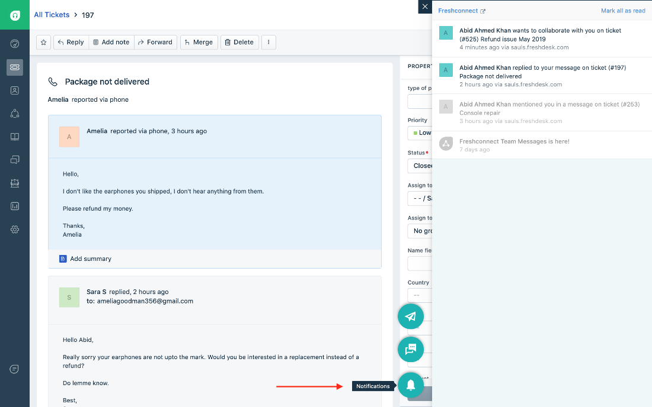

Figure 2 RRL: Freshdesk Interface Screenshot

The set of features introduced in this software focuses on helping the users maximize their worktime by utilizing the creation and organization of tickets such as the Team Inbox for tracking the incoming tickets from a multitude of channels, Agent Collision Detection to avoid having the different personnel work on the same ticket. They also include a self-service feature so that customers can solve their own problems without the need to contact a live person by using forums and articles. They also have a feature to organize the team’s tasks so that they can improve the efficiency of their work [6].

### 2.2.2 Spiceworks

*Spiceworks* is another IT helpdesk ticketing system that is free and is cloud-based [7].



Figure 3 RRL: Spiceworks Logo

The highlight of this software is that because it is cloud-based, it can support ticket organization and management even when an organization has branches in different areas or when they have remote employees.

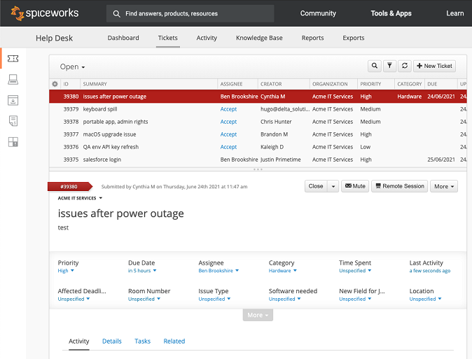

Figure 4 RRL: Spiceworks Interface

It has the ability of managing IT-support tickets by having the features such as the accepting, replying, and commenting on tickets, custom field tracking, self-service system, and integration with other software such as Power BI for business analytics. It also has features for team collaboration, and it includes help desk team management that monitors the performance of each organization members, ticket collaboration where other members can help one in need in solving a ticket, and a multi-site support that will cater all the organization members even in those who are in different areas and the ability to integrate it with the master or the center help desk.

### 2.2.3 LiveChat

LiveChat is an application that is dedicated for customer care and a tool for e-commerce [8].



Figure RRL: LiveChat Logo

The highlight of this system are its widgets, small dashboard that includes chat, SMS and email. It also offers integration with common software platforms such as Salesforce, Facebook messenger, etc. It has share announcement, and a function to introduce new products via chat and caters personalized readings as it is mainly used for e-commerce [9].

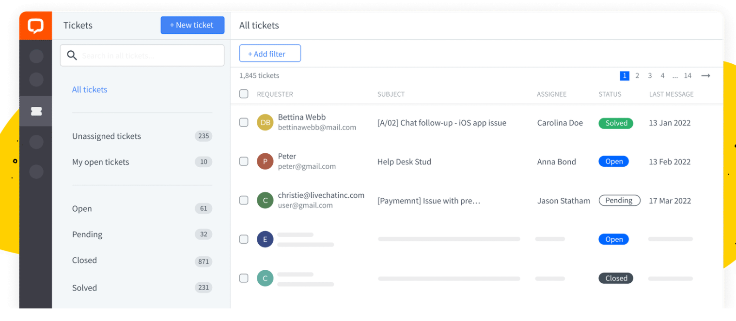

Figure RRL: LiveChat Interface

### 2.2.4 Hiver

Hiver is a Software-as-a-Service application that collaborates with email for better customer support organization. It is also known that Hiver is used for Harvard University’s customer communication [10].



Figure RRL: Hiver Logo

The highlight of this system includes streamlining incoming emails. It turns emails into actionable tasks and delegate them to the team members with just 2 clicks. Mark emails as Open, Pending, or Closed and always keep a tab on their status. It also makes internal team collaboration easier as it uses notes to collaborate with the team to respond to inquiries or solve issues that the staff and students may be facing without relying on email forwards, Ccs or external collaboration tools. Mentioning teammates is also a feature to notify them and have them respond to issues faster. It makes response faster with email templates because Administrative and IT teams in educational institutes usually spend a lot of time answering repetitive queries. This system creates email templates and use them right from the Gmail compose window for lightning-fast replies. Lastly, it puts an end to missed emails because of the creation of SLA (Service Level Agreement) rules that ensures a never miss responding to an email. When an SLA is violated, Hiver sends an instant notification to the team and attaches an SLA violation tag to the email. This SLA violation is also seen in the email activity feed.

### 2.2.5 LiveAgent

LiveAgent is a live chat software that improved to be an entire customer service platform [11]. This system is known to be utilized by the UEI College – Fresno [12].



Figure RRL: LiveAgent Logo

Features includes chat specific analytics to get more insight into customer interactions, also creates proactive chat messages to make sure the staff get in front of people at the right time. eliminates account sharing, SLA and action triggered automation rules. It has fully customizable self-service and customer support with FAQ, Forums, and an integrated guide [13].

### 2.2.6 Zendesk

*Zendesk* is a software that is one of the most famous ticketing system software for customer support being this specific service as one of their core competencies. Because of their wide-range system, it is best used as a school help desk for large departments with big budgets [11]. Some schools that used this software includes (1) University of Louisville in Louisville, Kentucky (2) Ohio Wesleyan University in Delaware, Ohio (3) USC Annenberg School for Communication and Journalism, Los Angeles, CA and Beloit College, City in Wisconsin [14].



Figure RRL: Zendesk Logo

Highlight features includes Customized views Live chat and messaging, automated routing, a knowledged-based software, community forums, and multi-language support.

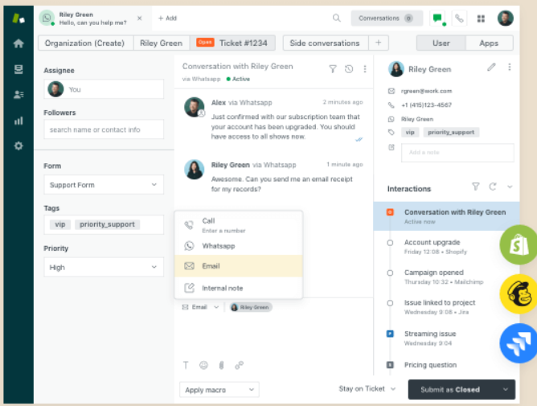

Figure RRL: Zendesk Interface

### 2.2.7 Help Scout

Help Scout is a software that is dedicated for email management and is best used for student communication in an institution [11]. Some of the schools that utilized the features of this system are the University of Hawaiʻi at Mānoa in Honolulu, University of Oregon in Eugene, Oregon, and University of Amsterdam in Netherlands



Figure RRL: Help Scout Logo

Some features that make the most of Help Scout are their shared inboxes wherein there is a private note and @mentions to make team collaboration a breeze, collision detection which reduces agent’s duplicate work, automated routine tasks like sorting and assigning incoming requests based on parameters and enables creation of powerful self-service resources like FAQ pages or a knowledge base with Docs [15].

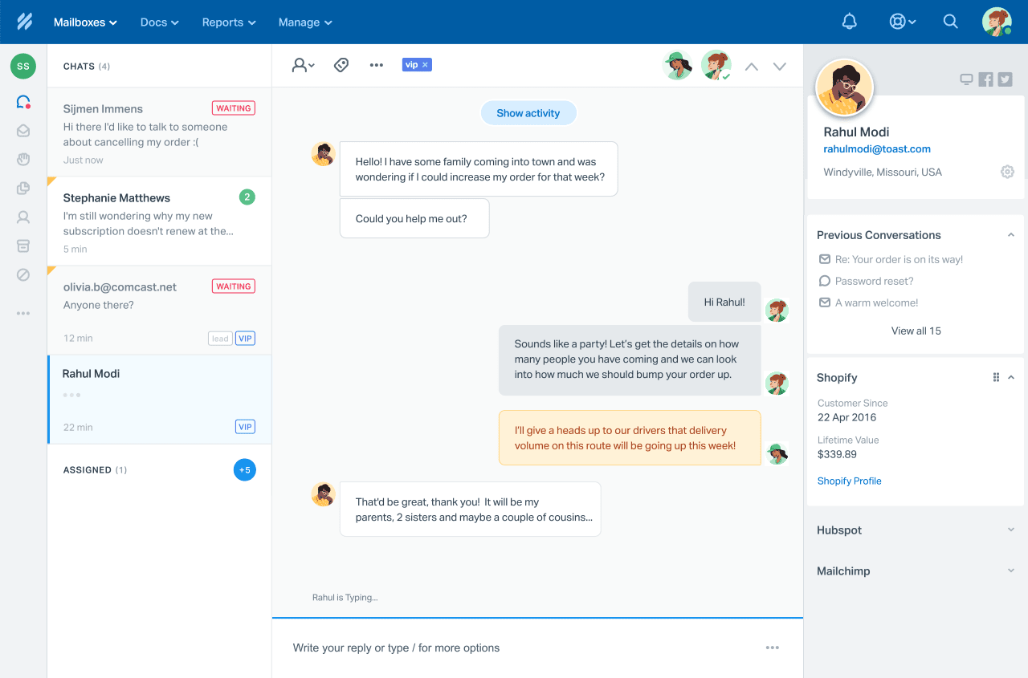

Figure RRL: Help Scout Interface

### 2.2.8 SolarWinds

SolarWinds is a cloud-based application that is focused and utilized primarily by IT departments [16]. Their key features include checking and updating status and information of their tickets, replying to ticket with an email, notifying tech support of the tickets. They also have a Solutions database that caters resolution for known or common issues. They also provide a service catalog so that their customers are aware of the services they offer.



Figure RRL: SolarWinds Logo

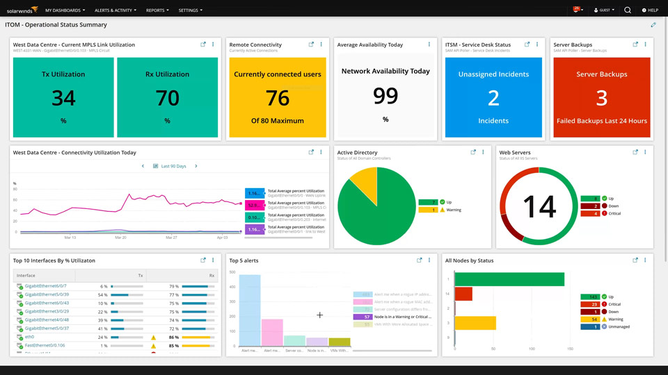

Figure RRL: SolarWinds Interface

These systems (as seen in the figures above) can be a good reference in the team’s project proposal as it can help us see which process from the IT ticketing systems are overused, can be innovated further, and the gap that the team can provide a solution to.

The related system and literature included in this study have significant relationship with the future project in the sense that it can be deemed useful for the client, students, teachers, as well as the school and the rest of its staff, that is of concern to the system being developed.

The ITRO, as the client, would be able to maximize the use of their limited schedule by allowing the developers to see through these materials and improve the application, making them even more efficient.

The students and teachers on the other hand could read about these as well and find more ways as to how they could implement or suggest any other ways to improve the software to be developed for them to know how it works and how they could fully utilize it.

# Current System

The current system being utilized is a dated, and ironically manual approach since the ITRO’s workflow and every other transaction revolve around the use of electronic messaging or emails.

## 3.1 Technical Background

### 3.1.1 MS Outlook

It is used by the current system as a platform for sending email requests to admin, specifically to the head of the department which filters the request for approval.

### 3.1.2 Internet Connection

The current system also requires internet connection for the email requests to be sent by end user to the admin.

## 3.2 List of Processes

Table 1 Current System: List of Processes

|  |  |  |
| --- | --- | --- |
| Process ID | Process  Name | Process  Details |
| P001 | Sending Emails | 1. Client needs to identify the subject for query  2. Choose where to send between the two email-support of ITRO  3. Iterate the issues or the problem that occurred |
| P002 | Sorting Emails | 1. Admin receives the query  2. Opening the e-mails one by one  3. Identify the subject of the query  4. Set prioritization over requests  5. Assigning queries to other ITRO staff member |
| P003 | Providing Feedback | 1. Client waits for the admin response about the status of the query  2. Assigned ITRO staff resolves the task  3. ITRO staff sends a reply to their client |

## 3.3 SWOT Analysis

Table 2 Current System: SWOT Analysis

|  |  |
| --- | --- |
| **ITRO EMAIL-BASED WORKFLOW**  *(CURRENT SYSTEM)* | |
| **STRENGTHS** | * Easily accessible * Common and widely utilized by professionals * Easy to manipulate |
| **WEAKNESSES** | * Prone to being convoluted and hard to organize * Dated and often not utilized by students compared to other messaging applications * It could be hard to navigate and filter through various spam and promotional mails and advertisements * Promotes distraction for the user due to the crowded interface * No tools provided for data analysis |
| **OPPORTUNITIES** | * This could be further improved if the developers would want to * There is a plethora of tutorials regarding several features that most users are not aware of * Suitable for growing use of cloud services |
| **THREATS** | * Since emailing applications are meant to serve as an app made primarily for communications, and productivity second, the existence of other mainstream applications that are much more convenient in the respective fields of communications and productivity means overshadows its user existence. * Environmental issues regarding the excessive use of emails * Human error (e.g., sending email to wrong person, incomplete email details) |

# Proposed Solution

The team proposes the use and development of the project dubbed as RAMS Corner: An Intuitive Ticketing Service for ITRO Queries and Schedule Management in lieu of electronic mailing and traditional methods

## Technical Background

### 4.1.1 Desktop Computer/ Mobile Phone

The proposed application is a reactive web-app that can be deployed in browsers of both mobile and desktop computers.

### 4.1.2 Internet Connection

The proposed system will also require internet connection for the raising and receiving requests on both the admin and client side.

## 4.2 Feasibility

### 4.2.1 Operational Feasibility

Although the current system of ITRO is well-liked, it is not as effective because the ITRO staff still have complaints about work overloading, especially when there is only one person doing all the work. In any case, the new system will not require them to reduce the workforce, rather, it will help the staff members to have the work assigned to them and be organized to improve the efficiency of their work. The new system is already widely used in different industries; thus, training will not be necessary. A user manual will suffice for the employees to learn the loops of using the new system by themselves. The ITRO is involved in the decision-making and the planning of features process as they will be the ones to provide information about their workflow. Upon the deployment of the new system, it will not demand operation changes as the ITRO will still use their previous gadgets in completing the requests they will receive such as their phones and any other computing devices, and they will still accept and assist request from their clients just as they usually do. Their service performance will not, in any way, decline as the newly proposed system will enhance their organization of tasks, and therefore will lead to a more proficient way of handling their work whilst the requests are going in and double in number. By this, the gain of the ITRO outweighs the individual losses or can be simply said as *there will be no losses at all* since the new system works in favor of the workflow of the ITRO. They may experience adverse effects – in the way that they must familiarize themselves again with the new system, but it will only affect them mildly and only in a small span of time. Also, the new system does not pose any risk, rather, it will be a good thing for both the ITRO and their clients. There are no legal or ethical issues present or to be considered as the new system works the same as the previous system, only, with a more intuitive interface, enhanced organization of tasks and categorizations.

### 4.2.2 Economic Feasibility

The deployment and usage of the app will not cost the ITRO any monetary value as the application will be run only in browsers. The hardware, or the equipment to be used to run this application is already available and need not buy new units of computing devices nor added bills in internet connection. Only, intangible cost may be a lot more expensive than that of the tangible cost that will be consumed in the earlier phase because this will include time, as the ITRO needs to familiarize themselves in the new system. Tangible benefits will be visible in the long run because the new system includes a tool that can prioritize, organize, and can be used to assign equal work to the ITRO staff. In this way, they can save time resolving requests. Intangible benefits include the ITRO clients’ satisfaction with a new requesting system because they need not create redundant emails and can easily send requests using the categorized tags in creating tickets, hence, ITRO can receive more requests that may have an impact on their client-satisfaction ratings. It is also a satisfactory application for the admin because he can divide the work to his personnel– equally – and evaluate the work of ITRO in general by using the analytics part of the application.

### 4.2.3 Technical feasibility

The ITRO already has the necessary computing devices to be used in deploying the application and internet connection is already installed on the premises. The ITRO, being the office that handles IT-related requests, already has the perfect staff who know the practice of troubleshooting software and hardware devices and some other problems that can occur when using the application. Also, the app will be flexible enough so that the ITRO can modify the application based on their needs in the future and can also be integrated with the database of the school to recognize the clients that can be accommodated by the app. Nevertheless, the ticketing system will last for a long time since people are looking for an effortless way to communicate through their requests.

### 4.2.4 Schedule Feasibility

There will be no hindrance when it comes to scheduling when using the new application as it is operated just like how ITRO manages the requests they receive via email. Only, the new app is more comprehensive in organizing, prioritizing, and assigning of tasks that can improve the work schedule of the ITRO staff.

## 4.3 Requirement Analysis

### 4.3.1 Product Vision

Table 3 Product Vision

|  |  |  |
| --- | --- | --- |
| **FOR** | APC Information Technology and Resource Office (ITRO) | ITRO Clients |
| **WHO** | Needs a way to organize and prioritize ITRO-related requests of students and teachers. | Needs a tool to organize their requests and see its status |
| **THE** | RAMs Corner: ITRO Ticketing Service | |
| **IS A** | Reactive Web App | |
| **THAT** | allows prioritization, organization, and designation of ITRO-related tasks and requests | allows automation of requests for uniformity and accuracy |
| **UNLIKE** | Using e-mails to receive requests | Using emails to write and send a request |
| **OUT PRODUCT** | Can be used in both web and mobile app for the ITRO’s convenience | Can be used in both web and mobile app for the clients’ convenience |

### 4.3.2 User Classes and Characteristics

Table 4 User Classes and Characteristics

|  |  |  |
| --- | --- | --- |
| ***GENERAL ROLES*** | ***ROLES*** | ***DESCRIPTION*** |
| ***Admin*** | ***ITRO Head and staff*** | The ITRO would be granted Admin privileges to view, mark, and respond to the requests and queries sent by users |
| ***Client*** | ***Teachers*** | Teachers as users could report various incidents involving—but not limited to—school tech problems, teaching method queries, facility maintenance, personal tech concerns, etc. |
| ***Students*** | Similarly, students as users could report various incidents involving—but not limited to—school tech problems, teaching method queries, facility maintenance, personal tech concerns, etc. |

### 4.3.3 Product Backlog/User Stories

Table 5 Product Backlog/User Stories

|  |  |  |  |  |
| --- | --- | --- | --- | --- |
| ID | As a… | I want to be able to… | So that… | Priority |
| 1 | Admin | Provide a list of categorized issues related to my department | I will not receive queries that are not aligned to our service | Must |
| 2 | Admin | Have the requests automatically assigned to my staff | I can maximize my time accommodating other requests | Could |
| 3 | Admin | Set the prioritization and urgency of the requests I receive | I will know what requests need immediate resolution | Must |
| 4 | Admin | Filter the requests based on their status | I will know what requests are near or far from its resolution | Must |
| 5 | Admin | Have my clients know what the status of their requests is | My clients can rest assured that we accommodate their requests | Must |
| 6 | Admin | Have a prepared list of common queries and how to solve them | I can minimize the percentage of redundant queries I receive | Must |
| 7 | Admin | login | I can manage the requests that the office receives | Must |
| 8 | Client | See a categorized list of services that the ITRO offers | I can know what the scope of their services that I can avail | Must |
| 9 | Client | Have an automatic request-maker | I do not have to spend time constructing a request | Could |
| 10 | Client | See a help desk with listed common issues and their resolution | I can save myself from sending an e-mail and wait for the resolution from the office | Must |
| 12 | Client | View the status of my requests | I will know if my request is well-received | Must |
| 13 | Client | login | I can ask for help regarding IT-related stuff | Must |
| 12 | Admin | Do a manual assignment of tasks to my staff | I can disseminate tasks equally in my department | Must |
| 13 | Admin | View how many requests the office receives | I can keep track on how many requests the office serves at a specific amount of time and do workflow revisions based on it | Should |
| 14 | Admin | View how many resolved requests there are | I can see the result of our department’s hard work | Should |
| 15 | Admin | View how many are the pending requests | I can adjust my time resolving other queries | Should |
| 16 | Admin | View how many cases are not resolved | My department can think of a new way to fix unresolved issues | Should |
| 17 | Admin | Generate reports about the requests | I can make a better decision upon how the department could improve its service | Must |
| 18 | Admin | View all the received tickets | I can know more information about what needs resolution | Must |
| 19 | Client | Send a personalized request | I can further explain the issue that I want to raise | Must |
| 20 | Client | Tag a related persona to my request | I can notify them of my queries as well | Must |
| 21 | Client | View all the tickets I have sent | I can keep track of the cases I raised to the office | Must |
| 22 | Admin | Make myself, my staff and our client have an option to reset our passwords, forgotten or not | We can keep ourselves secured in our own accounts | Should |
| 23 | Admin | Modify an account the client | I can add new clients to the server or remove or block a client from sending requests | Should |
| 24 | Admin | Show my client a photo of the resolution for their requests if needed | They can have a proper guide on the resolution of their request | Could |
| 25 | Admin | Limit our client from sending redundant requests | The office can prevent receiving spam and repeated cases | Could |
| 26 | Admin | See a notification of the requests sent to the office | I will be able to keep track of the incoming requests | Must |
| 27 | Client | Filter the notification I received | I would not be annoyed of receiving a lot of notification | Could |
| 28 | Admin | monitor the tasks that assigned to my staff member | I can maximize the utilization of the staff | Must |

### 4.3.4 Prototype

#### 4.3.4.1 Web View

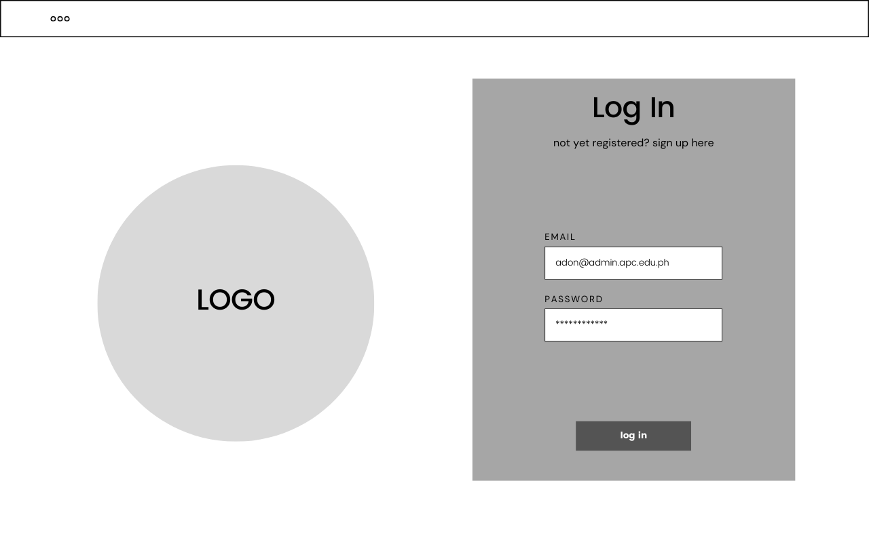

Figure 15 Web View - All User Login

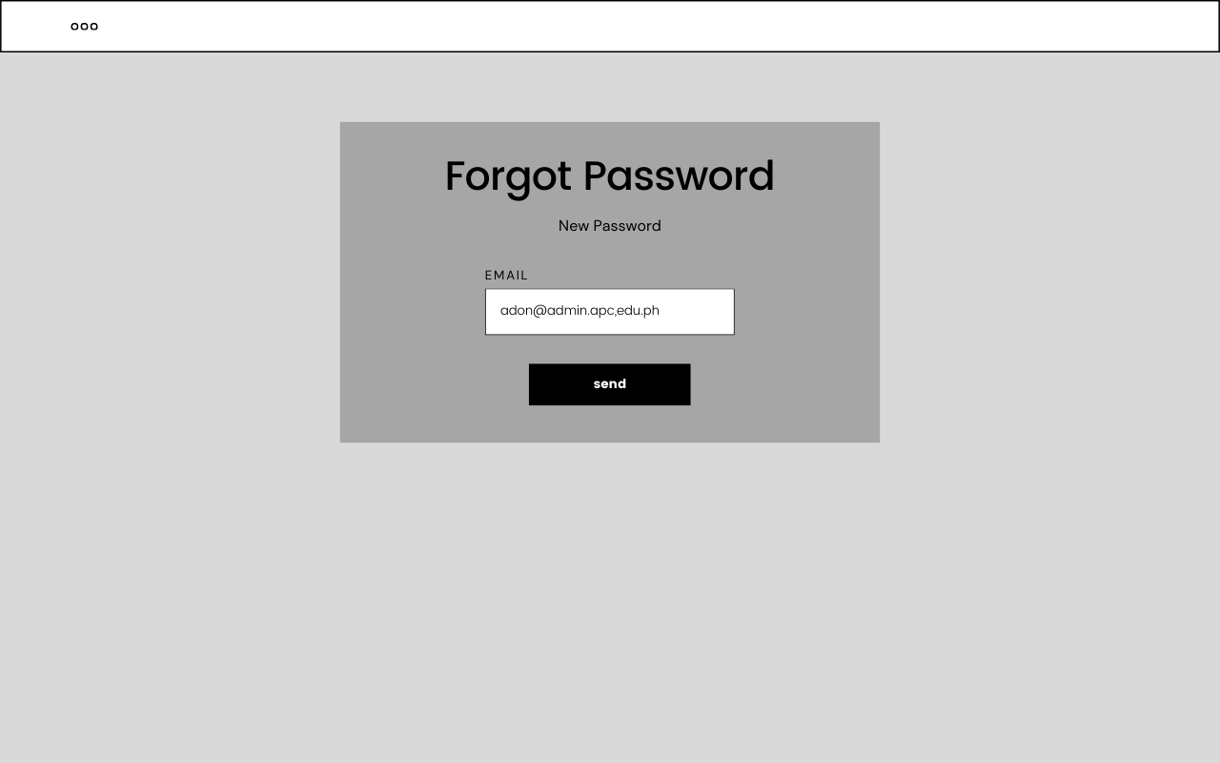

Figure 16 Web View - All User Forgot Password

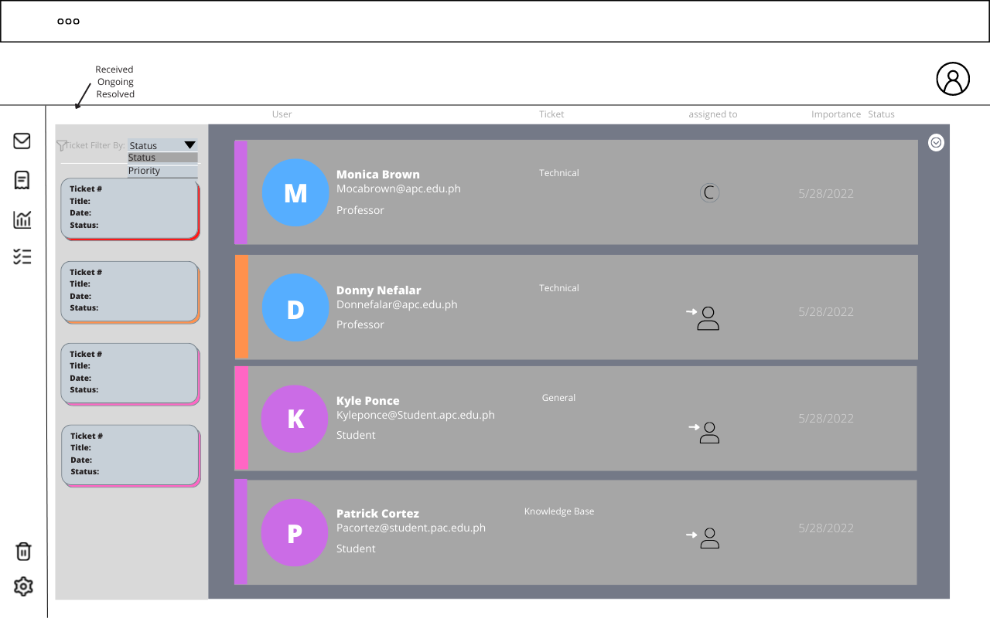

Figure 17 Web View - All Users View All Tickets

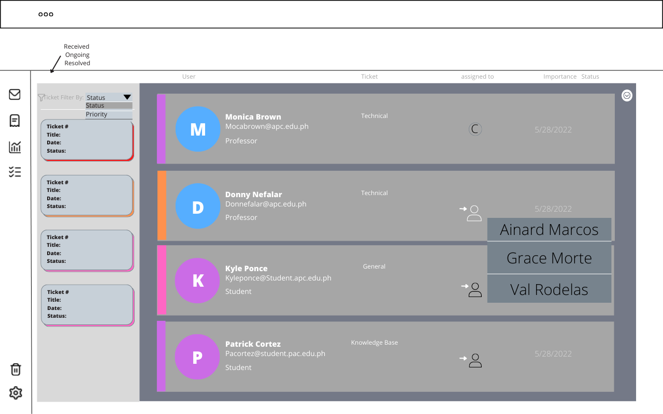

Figure 18 Web View - Admin Assign Tickets

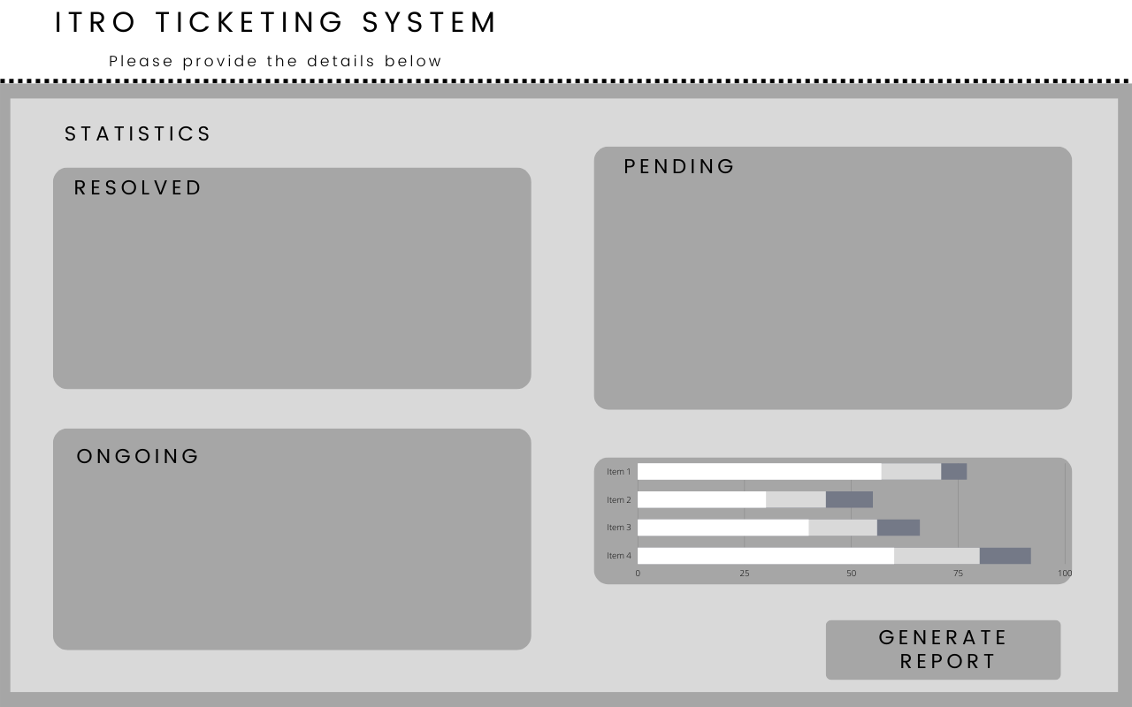

Figure 19 Web View - Admin Dashboard

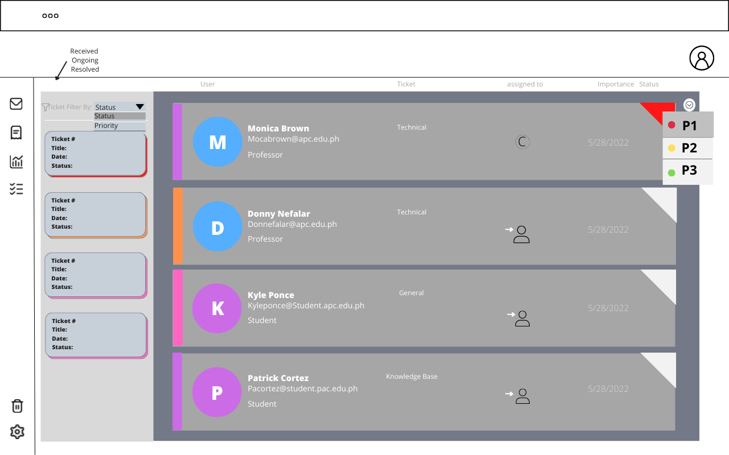

Figure 20 Web View - Admin Assign Ticket Priority Level

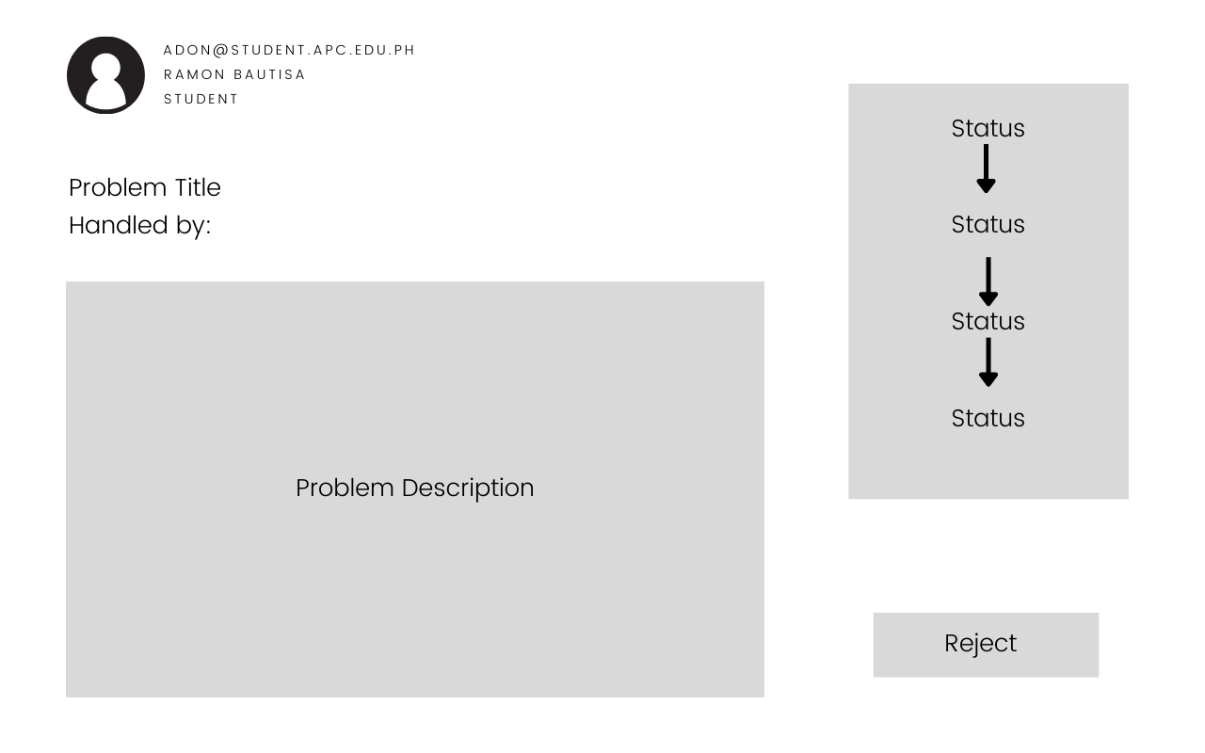

Figure 21 Web View - Admin Open Ticket View

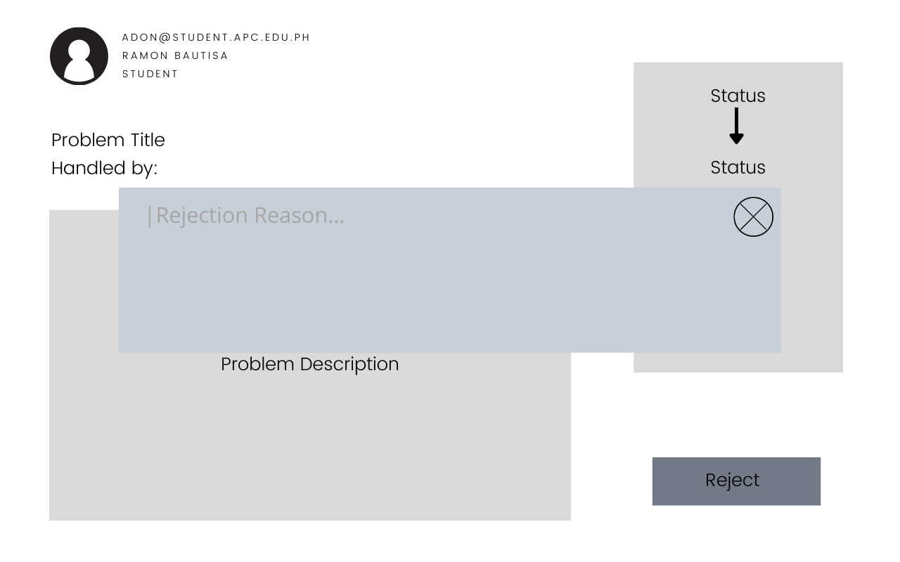

Figure 22 Web View - Admin Ticket Rejection

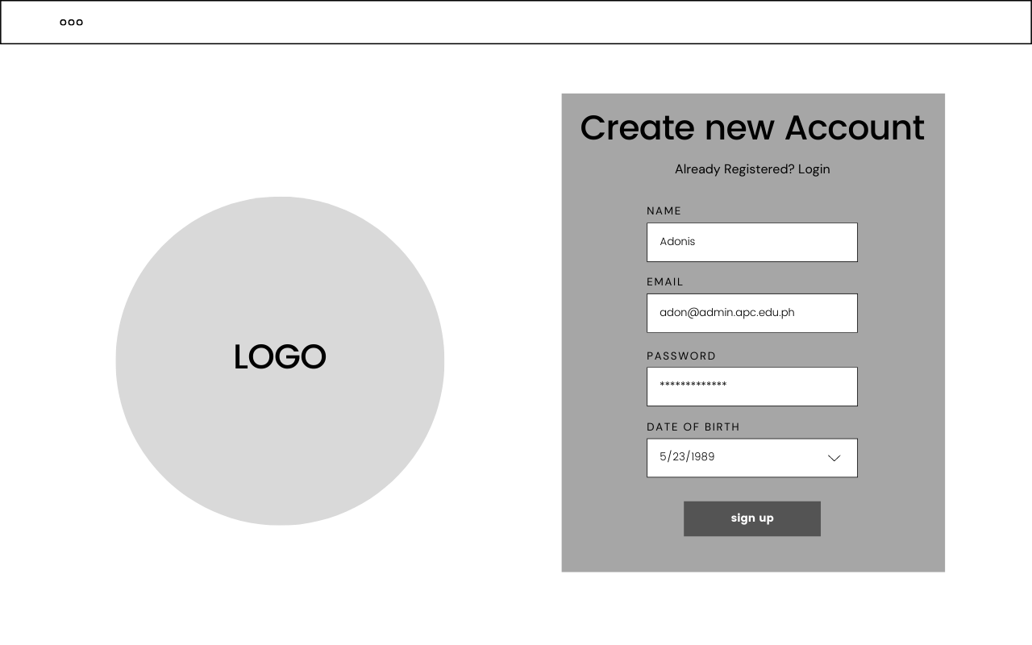

Figure 23 Web View - Admin Modify Client Credentials

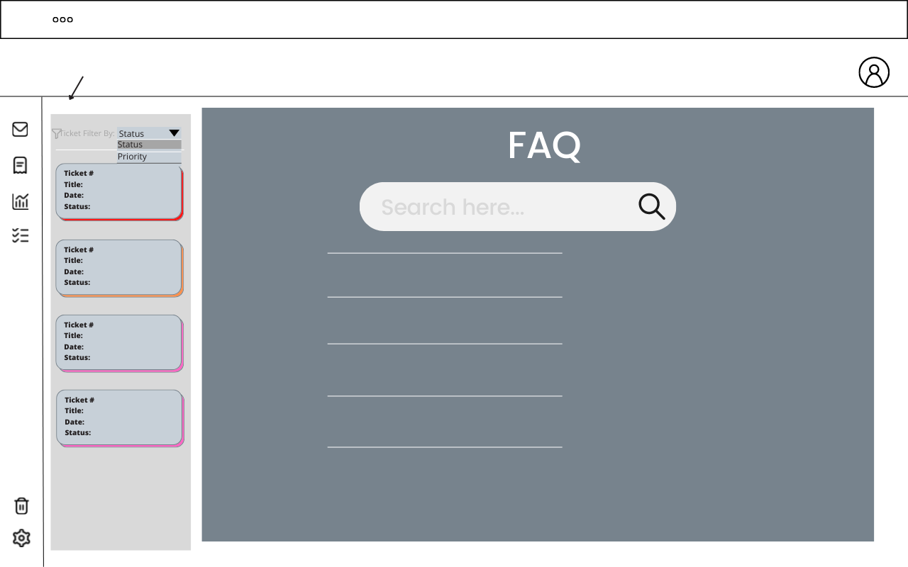

Figure 24 Web View - Client FAQ – Landing Page Interface

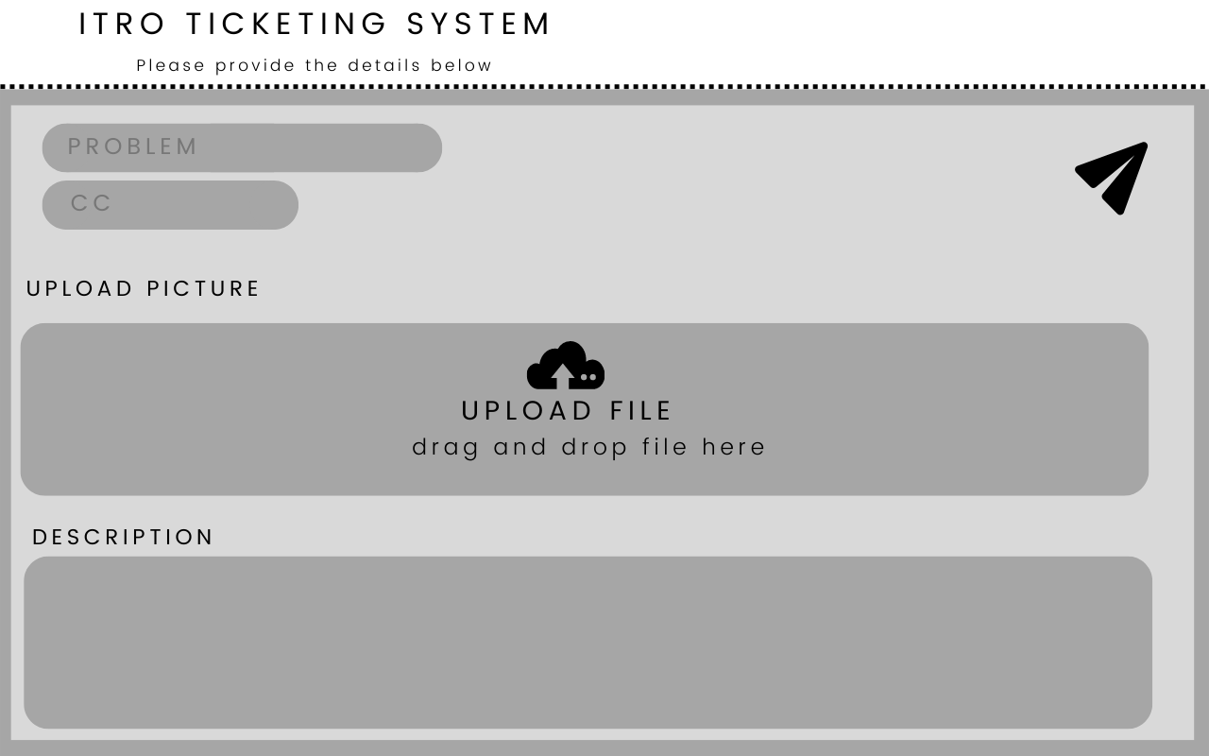

Figure 25 Web View - Client Send Tickets

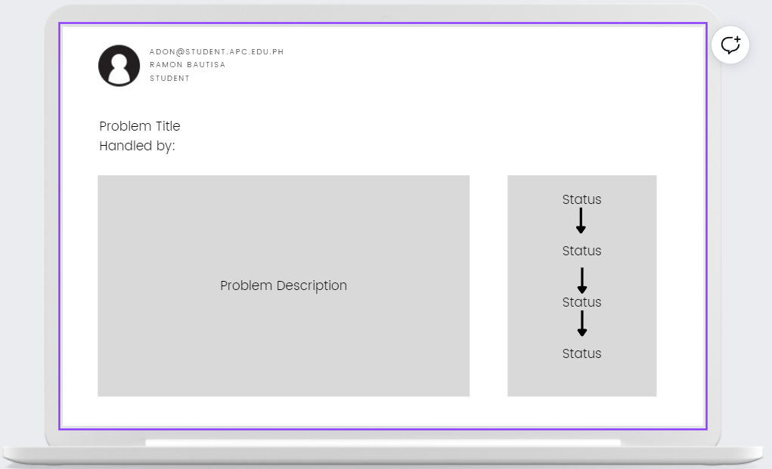

Figure 26 Web View - Client Open Sent Tickets

#### 4.3.4.2 Mobile View

Figure 27 Mobile View - All Users Login

Figure 28 Mobile View - All User View All Tickets

Figure 29 Mobile View - All Users View All Ticket

Figure 30 Mobile View - Admin Set Ticket Priority

Figure 31 Mobile View - Admin Modify Client Credentials

Figure 32 Mobile View - Admin Dashboard

Figure 33 Mobile View - Client Landing Page

Figure 34 Mobile View - Client FAQ Interface

Figure 35 Mobile View - Client Send a Ticket

### 4.3.5. Product Roadmap

Table 6 Product Roadmap

|  |  |  |  |
| --- | --- | --- | --- |
| **USERS** | **MNTSDEV** | **MSYADD1** | **MCSPROJ** |
| **ITRO**  **(Admin)** |  | * Admin manual ticket-assignment * View Insights/Analytics * Setting tickets’ urgency | * Automatic ticket-assignment * Ticket-Spamming Prevention * Modify user credentials * Problem Ticket/Incident Ticket categorization * Generate Reports * Monitoring Tasks assigned to staff |
| **Students and Teachers**  **(Clients)** |  | * User Ticket Creation * Cc Field * FAQs (Frequently Asked Questions) | * Automated ticket creation * Notification Filter * Categorization of ITRO-related tasks in subject field |
| **All Users** | * Paper Prototype | * User Login * Forgot Password * View All Tickets * Ticket Notification * Filter Ticket Status | * Option for Image attachment * View Ticket Progression |

### 4.3.6 Release Plan

***Release 1 – MSYADD1***

* ADMIN can open the web application using any browser
* ADMIN can log in on the application
* ADMIN can reset password if forgotten
* ADMIN can be notified of the incoming tickets
* ADMIN can manually assign tasks to the staff member
* ADMIN can set the priority level of the ticket
* ADMIN can filter the tickets received by their status and prioritization
* ADMIN can reply to the tickets sent by the user
* ADMIN can monitor the tasks assigned per staff member
* ADMIN can generate a softcopy of the report using the analytics/insights
* CLIENT can open the web application using any browser
* CLIENT can log in in the application
* CLIENT can add the web application on the home screen of their phones
* CLIENT can raise a ticket to the office
* CLIENT can tag a teacher on the Cc Field
* CLIENT can view all the tickets they raised
* CLIENT can filter the tickets they raised based on their prioritization and status
* CLIENT can access the FAQs for queries that they can solve by themselves

*Release 2 – MCSPROJ*

* ADMIN have a system that automate the assignment of tasks to the staff
* ADMIN can set a limit of the same request made by one user to avoid ticket-spamming
* ADMIN can add a new user to the system
* ADMIN can block a user
* ADMIN can delete a user from the system
* ADMIN can modify the credentials of the user
* ADMIN can view the progress of the ticket, whether it is pending, inspected, ongoing, or resolved
* ADMIN can view how many tickets are received per time-basis (daily, weekly, monthly)
* ADMIN can view how many tickets are resolved per time-basis (daily, weekly, monthly)
* ADMIN can view how many tickets are not resolved per time-basis (daily, weekly, monthly)
* ADMIN can view how many tickets are pending per time-basis (daily, weekly, monthly)
* ADMIN can view how many tickets are still ongoing or fixing per time-basis (daily, weekly, monthly)
* ADMIN can send an update and have an automated reply after of the status of the user’s ticket
* ADMIN have an option to attach an image in their reply to the tickets that are resolved
* CLIENT can select between the two tags with ITRO Scope
* CLIENT can choose a category of which their issue is about
* CLIENT can choose to automate the creation of their tickets by choosing a title on tickets list
* CLIENT can filter the notification they receive by their status
* CLIENT can attach an image to their tickets
* CLIENT can view the progression of their ticket, whether it is set pending, inspected, ongoing, or resolved

# V. Conclusion

The objective is to propose a project to the client wherein this app can help manage, prioritize, and organize the requests that they will receive from students and teachers alike whether they are inside or outside the school premises. Listed below are the things that we have done and what we are going to do in the future, to reach the team’s desired outcome.

## 5.1 What has been done:

1. Look for an adviser to help the team with decision-making and project proposals.
2. Look for a client who needs an IT solution in their respective jobs.
3. Propose a project to cater to the client’s needs – in the team’s case, an IT Ticketing Service
4. Jot down ideas for the features of the proposed application
5. Meeting with ITRO – interview about their needs and requests to feature in the app.
6. Meet with adviser – seek for more suggestions and improvement for the app
7. Meet with the ITRO Head – update the status of the application, entertain changes/improvements to be made on the app based on the client’s best interests
8. Improve the features of the application
9. Wireframe/Storyboarding
10. Create a mock-up/prototype
11. Video Pitch/Teaser
12. Project proposal paper polishing

## 5.2 What will be done for the next PBL subject:

1. Create Survey forms to be disseminated to APC Students and get their insights about the frequent IT-issues that they encounter.
2. Interview the faculty members – topic: frequent IT-related issues
3. Polish the application idea before modelling the database
4. Start developing the application after the modeling and design
5. Create and follow 1-week sprints to produce a minimum viable product to be presented to the client
6. Completion of the Application
7. Testing for the UI/UX and functions
8. Debugging
9. Retesting
10. Deployment

# References

|  |  |
| --- | --- |
| [1] | "Importance of information technology in today world," Digital Class World, June 2021. [Online]. Available: https://www.digitalclassworld.com/blog/importance-of-information-technology/#:~:text=Information%20technology%20helps%20to%20build,%2C%20storage%2C%20and%20efficient%20communication. [Accessed April 2022]. |
| [2] | M. C. Ferreira, T. G. Dias and J. F. e Cunha, "An In-Depth Study of Mobile Ticketing Services in Urban Passenger Transport: State of the Art and Future Perspectives," 2020. [Online]. Available: https://www.igi-global.com/chapter/an-in-depth-study-of-mobile-ticketing-services-in-urban-passenger-transport/249113. [Accessed April 2022]. |
| [3] | N. A. K. S. Mohamadali and G. J. M., "A NOVEL EVALUATION MODEL OF USER ACCEPTANCE OF," 2010. [Online]. Available: https://www.scitepress.org/papers/2010/26957/26957.pdf. [Accessed April 2022]. |
| [4] | S. Whittaker and C. Sidner, "Email Overload: Exploring Personal Information Management of Email," 1996. [Online]. Available: https://dl.acm.org/doi/fullHtml/10.1145/238386.238530. [Accessed April 2022]. |
| [5] | P. O. Calora, D. S. Maranan and C. Rose, "Exploring the Potential of a Ticketing-Based Student Support System for Open and Distance," December 2020. [Online]. Available: https://ijodel.com/wp-content/uploads/2021/08/004_Calora_et_al.pdf. [Accessed April 2022]. |
| [6] | "Freshdesk Support Desk," Freshworks Inc., 2022. [Online]. Available: https://freshdesk.com/support-desk/features. [Accessed April 2022]. |
| [7] | Spiceworks, "The cloud help desk software for IT. For Free.," Spiceworks, 2022. [Online]. Available: https://www.spiceworks.com/free-help-desk-software/. [Accessed 17 May 2022]. |
| [8] | LiveChat, "Who we are and what we do," LiveChat, [Online]. Available: https://www.livechat.com/about/. [Accessed 19 June 2022]. |
| [9] | LiveChat, "Features: Ticketing System," LiveChat, [Online]. Available: https://www.livechat.com/features/ticketing-system/. [Accessed 19 June 2022]. |
| [10] | Hiver, "Customer Service Software for Education | Hiver," Hiver, [Online]. Available: https://hiverhq.com/helpdesk-software-education. [Accessed 19 June 2022]. |
| [11] | J. Short, "The 9 Best Help Desk Software for Schools and Universities," HelpScout, 8 June 2022. [Online]. Available: https://www.helpscout.com/blog/help-desk-software-for-schools/. [Accessed 19 June 2022]. |
| [12] | Enlyft, "Companies using LiveAgent," Enlyft, [Online]. Available: https://enlyft.com/tech/products/liveagent. [Accessed 19 June 2022]. |
| [13] | LiveAgent, "Features - LiveAgent," LiveAgent, [Online]. Available: https://www.liveagent.com/features/. [Accessed 19 June 2022]. |
| [14] | Aendesk, "Education Help Desk Software & Customer Service Software," Zendesk, [Online]. Available: https://www.zendesk.com/education/. [Accessed June 2022]. |
| [15] | H. Scout, "Help desk Software for Education - Help Scout," Help Scout, [Online]. Available: https://www.helpscout.com/industry/education/. [Accessed June 2022]. |
| [16] | C. o. t. H. Cross, "IT Service Desk | College of the Holy Cross," Colleg of the Holy Cross, [Online]. Available: https://www.holycross.edu/its-help-desk/it-services/support-training/it-service-desk. [Accessed June 2022]. |
| [17] | "Freshworks: About Us," Freshworks Inc., 2022. [Online]. Available: https://www.freshworks.com/company/about/?source=freshdesk&medium=referral&campaign=fdesk_footer_main. [Accessed April 2022]. |

# Appendices

# Appendix A: Roles and Responsibilities

Table 7 Appendix B: Table of Schedule

|  |  |  |  |  |  |
| --- | --- | --- | --- | --- | --- |
| **WEEK NO** | **SCHEDULED DATE** | **TASK** | **ASSIGNED TO:** |  | **Nacor Industries Members:** |
| ***2*** | *3/28/2022* | Look for Adviser | *PC, RM, VN, AN, KP* |  | **PC** - Patrick Cortez |
| ***3*** | *04/01/2022* | Look for Client | *PC, RM, VN, AN, KP* |  | **RM** - Ruth Morallos |
| ***4*** | *4/5/2022* | Adviser Confirmation | *VN* |  | **VN** - Vincent Nacor |
| *4/7/2022* | Project Proposal Brainstorming | *PC, RM, VN, AN, KP* |  | **AN** - Allan Vincent Nefalar |
| ***5*** | *4/12/2022* | Ticketing System Feature Ideas | *PC, RM, VN, AN, KP* |  | **KP** - Kieyl Ponce |
| *4/18/2022* | Adviser Signed Form - Follow Up | *VN* |  |  |
| Send e-mail to possible client | *KP* |  |  |
| *4/19/2022* | Meeting with Adviser | *PC, RM, VN, AN, KP* |  |  |
| *4/21/2022* | Problem Rundown | *KP, RM* |  |  |
| S.W.O.T Analysis | *PC, RM, VN, AN, KP* |  |  |
| *4/22/2022* | Wireframe/Storyboarding | *VN, AN, PC* |  |  |
| Meeting with Client (ITRO) | *PC, RM, VN, AN, KP* |  |  |
| User Needs Statement | *RM* |  |  |
| ***6*** | *4/25/2022* | Project Proposal: Chapter 1 & 2 - Compile | *PC, RM, VN, AN, KP* |  |  |
|  | Intro & Abstract | *KP* |  |  |
|  | Project Context | *RM* |  |  |
|  | Statement of the Problem | *RM* |  |  |
|  | Objectives | *VN* |  |  |
|  | Significance | *PC* |  |  |
|  | Scope and Limitations | *AN* |  |  |
|  | RRL | *PC, RM, VN, AN, KP* |  |  |
| *4/28/2022* | Project Proposal: Chapter 3 & 4 - Compile | *PC, RM, VN, AN, KP* |  |  |
| *4/29/2022* | Project Proposal: Chapter 5 & Appendix - Compile | *PC, RM, VN, AN, KP* |  |  |
| *4/29/2022* | Project Proposal Proofreading and Editing | *KP* |  |  |
| *4/30/2022* | Project Proposal Completion | *PC, RM, VN, AN, KP* |  |  |
| **7** | *05/04/2022* | Pre-defense | *PC, RM, VN, AN, KP* |  |  |
| **8** | *05/10/2022* | Progress meeting with Client | *PC, RM, VN, AN, KP* |  |  |
|  | *05/12/2022* | Paper Revision | *PC, RM, VN, AN, KP* |  |  |
|  | *05/12/2022* | SOP Progression (V.1) | *RM, KP* |  |  |
|  | *05/12/2022* | Objective Progression (V.0) | *RM, KP* |  |  |
|  | *05/12/2022* | Comment Matrix | *RM* |  |  |
| **9** | *05/16/2022* | SOP Progression (V.2 – V.5) | *RM, KP* |  |  |
|  | *05/17/2022* | Progress Meeting with Client | *PC, RM, VN, AN, KP* |  |  |
| **10** | *05/23/2022* | Objectives Progression (V.1 – V.3) | *RM, KP* |  |  |
|  | *05/24/2022* | Meeting with Client | *PC, RM, VN, AN, KP* |  |  |
| **11** | *05/30/2022* | Progress Meeting with Members | *PC, RM, VN, AN, KP* |  |  |
|  | *05/30/2022* | Features Planning and Polishing | *PC, RM, VN, AN, KP* |  |  |
|  | *05/30/2022* | Product Vision (V.0) | *RM* |  |  |
|  | *05/30/2022* | Product Roadmap (V.0) | *RM* |  |  |
|  | *05/30/2022* | Release Plan (V.0) | *RM* |  |  |
|  | *05/30/2022* | Product Backlog (V.0-V.1) | *RM* |  |  |
|  | *05/31/2022* | Meeting with Project Adviser | *PC, RM, VN, AN, KP* |  |  |
|  | *05/31/2022* | Product Vision (V.1) | *RM, VN, KP* |  |  |
|  | *05/31/2022* | Product Roadmap (V.0-V.1) | *RM, VN, KP* |  |  |
|  | *05/31/2022* | Release Plan (V.0) - Continuation | *RM, VN, KP* |  |  |
|  | *05/31/2022* | Product Backlog (V.1) | *RM, VN, KP* |  |  |
|  | *05/31/2022* | Video Pitch/Teaser Editing | *PC, VN, AN, KP* |  |  |
|  | *06/01/2022* | Final Paper Editing/Polishing | *PC, RM, VN, AN, KP* |  |  |

## Appendix B: Teams Meetings/Minutes of Meetings

*Microsoft Teams – Meeting with Members: Apr-11-2022*

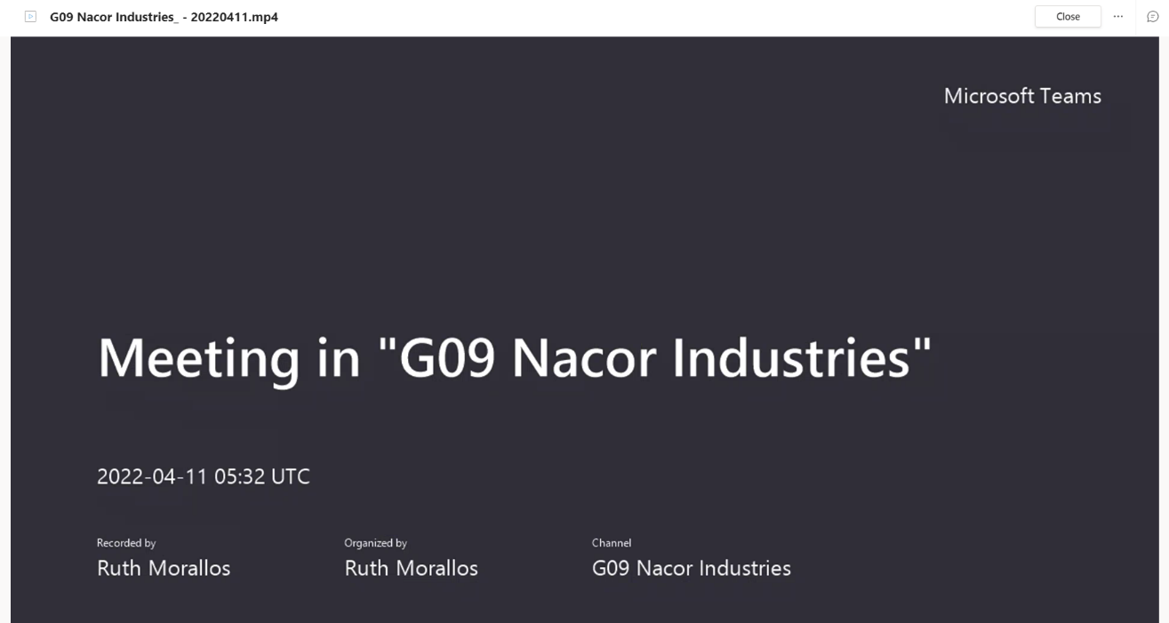

Figure 36 Microsoft Teams – Meeting with Members (1)

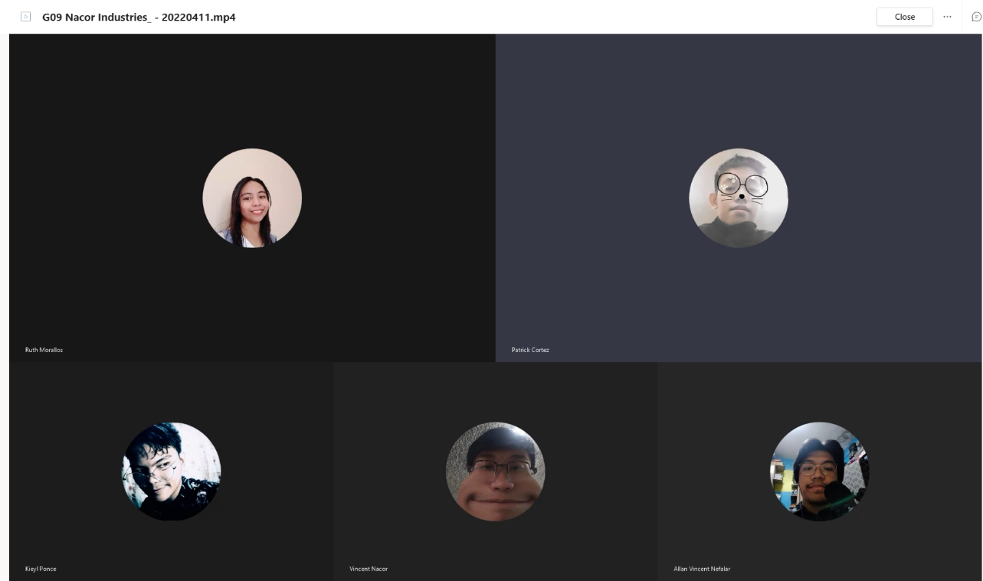

Figure 37 Microsoft Teams – Meeting with Members (2)

*Face-to-face – Meeting with Members: Apr-19-2022*

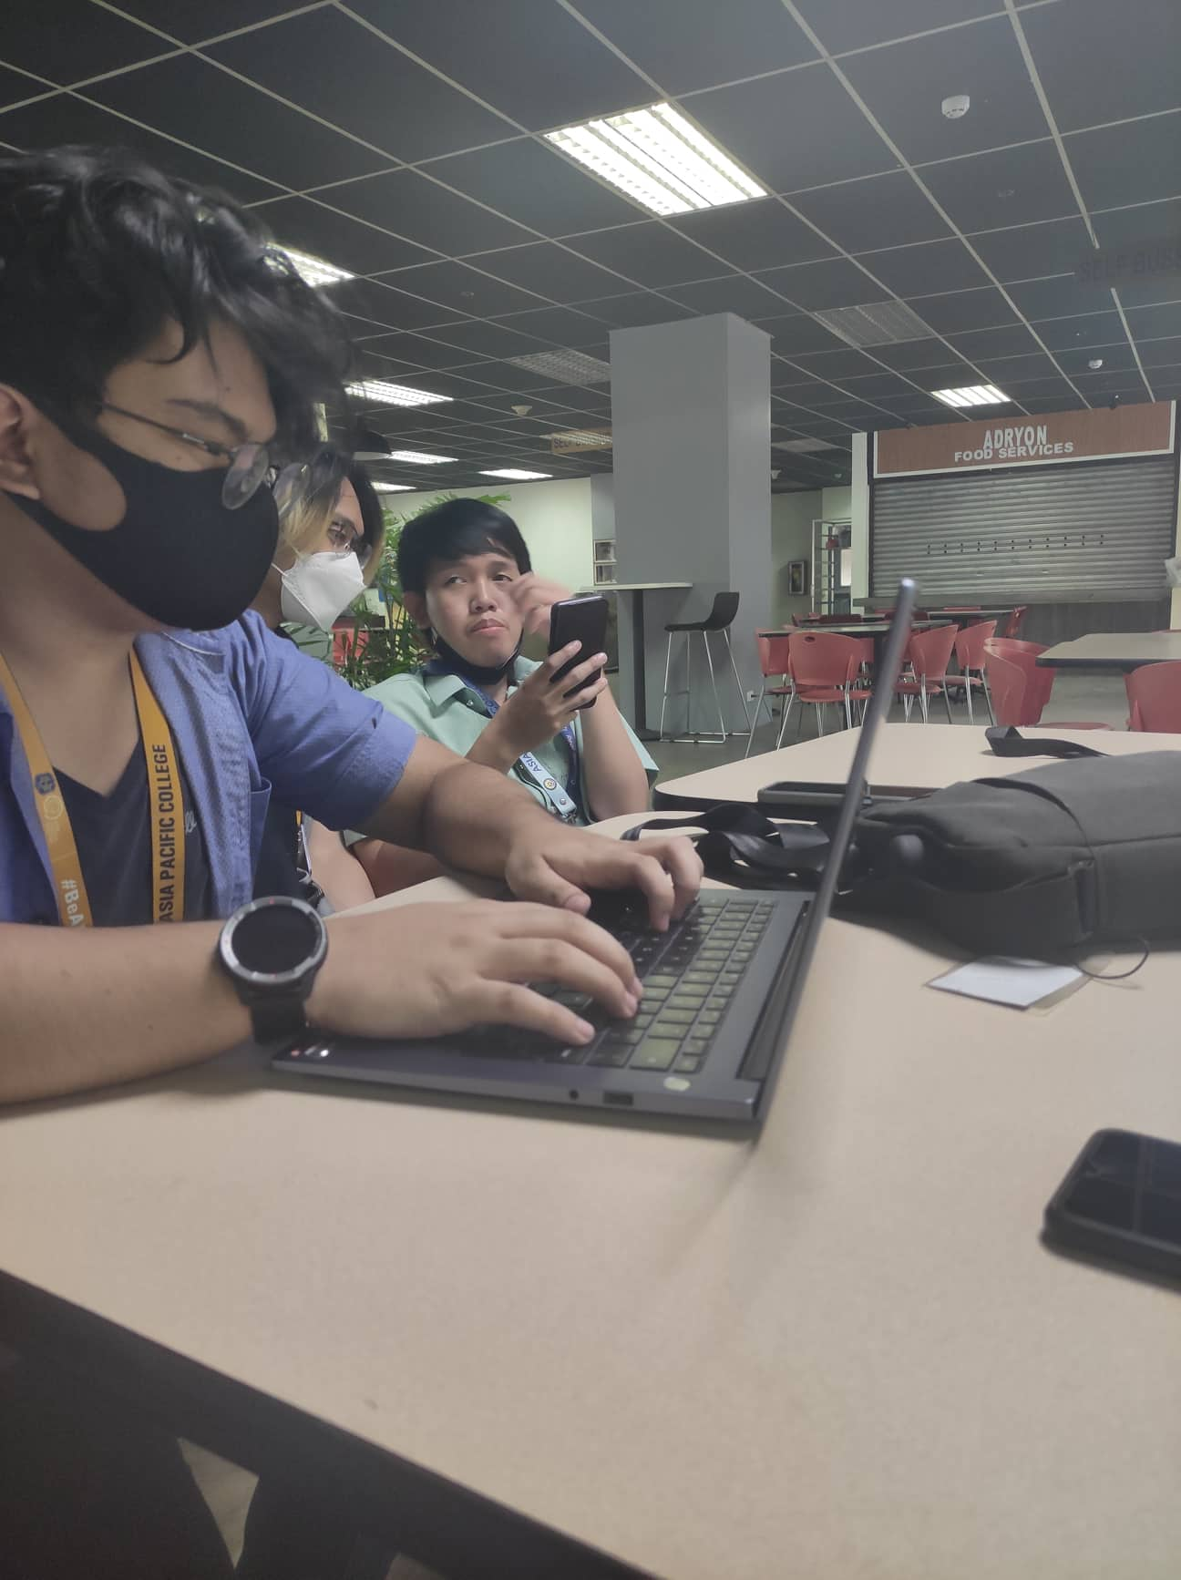

Figure 38 Face-to-face – Meeting with Members (1)

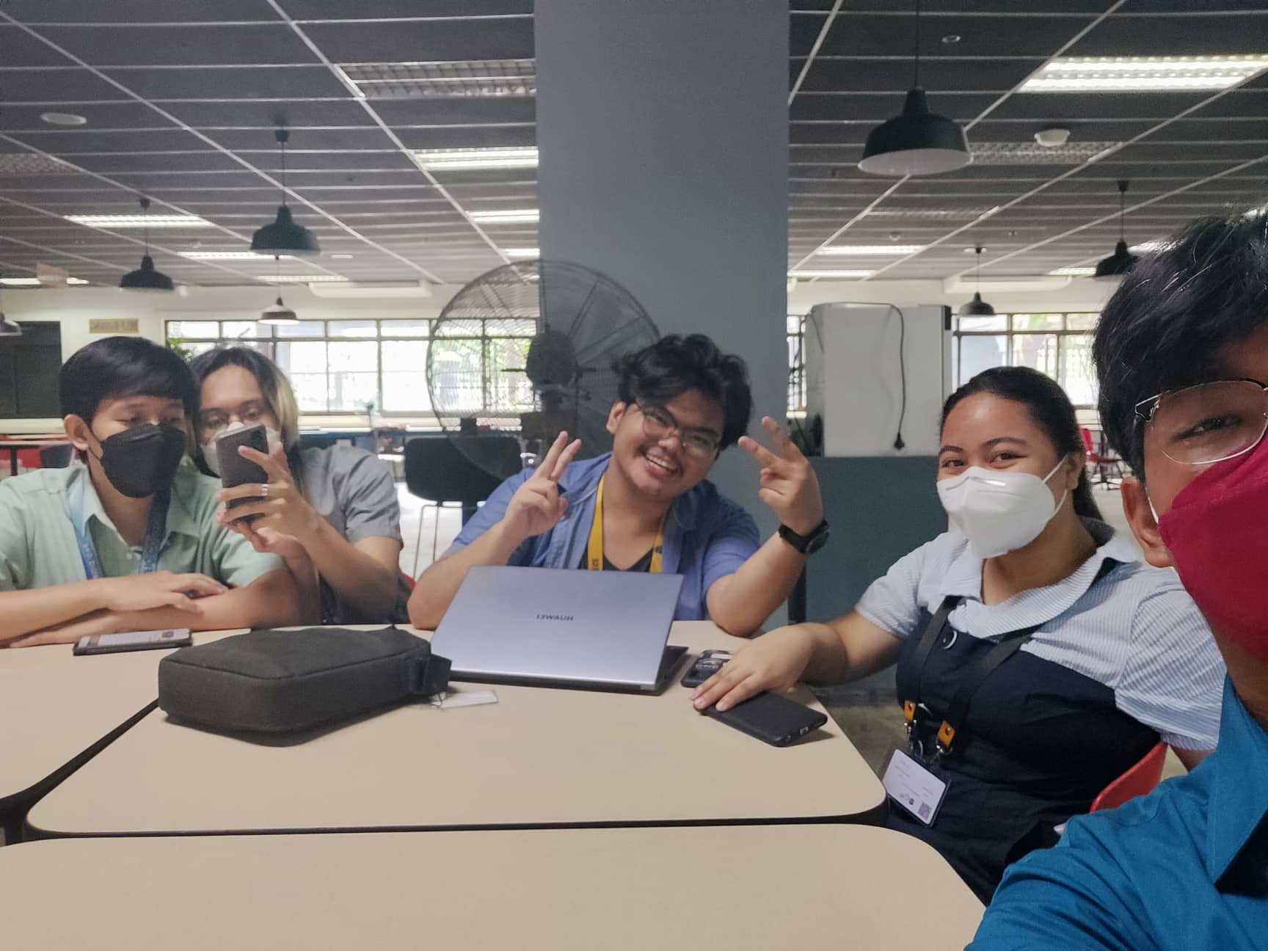

Figure 39 Face-to-face – Meeting with Members (1)

*Face-to-face – Meeting with Members:* Apr-22-2022

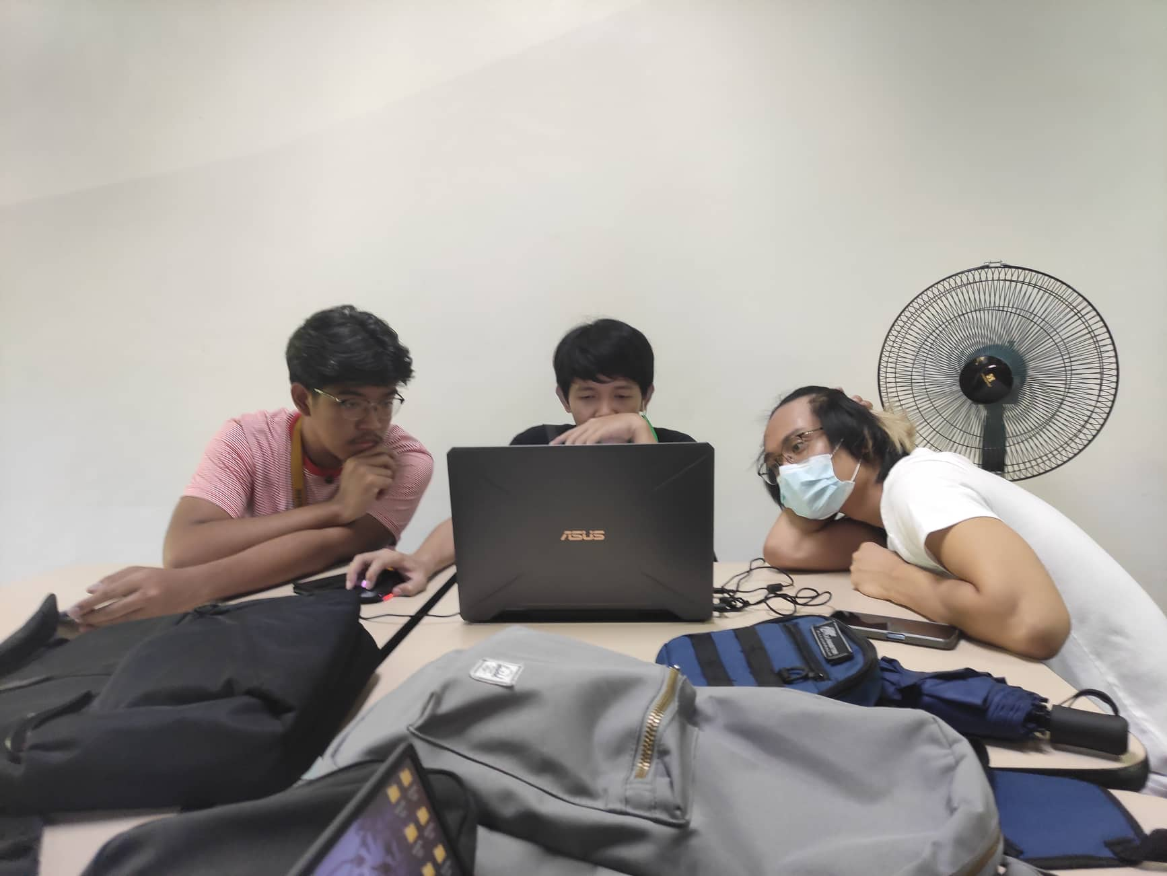

Figure 40 Face-to-face – Meeting with Members (3)

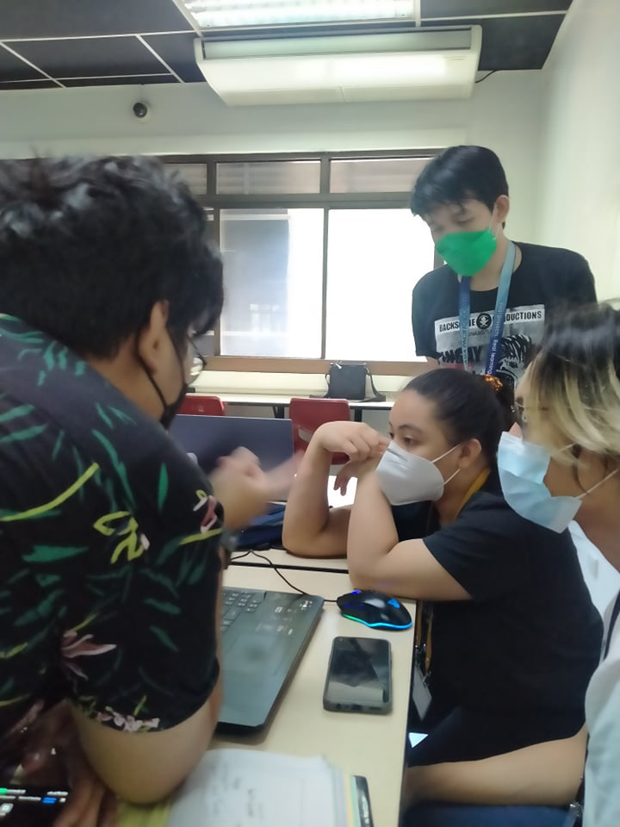

Figure 41 Face-to-face – Meeting with Members (4)

*Microsoft Teams – Progress Meeting with Members: Apr-27-2022*

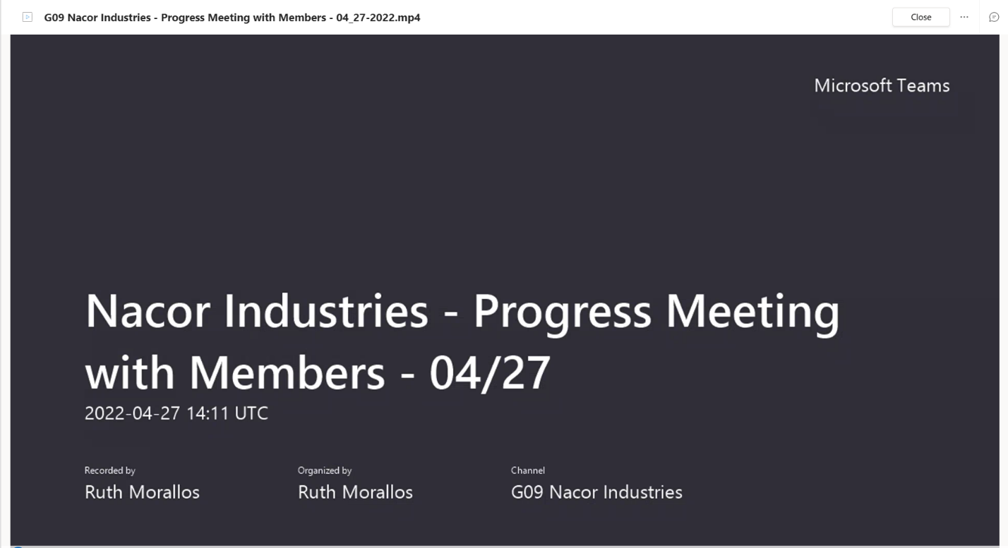

Figure 42 Microsoft Teams – Meeting with Members (3)

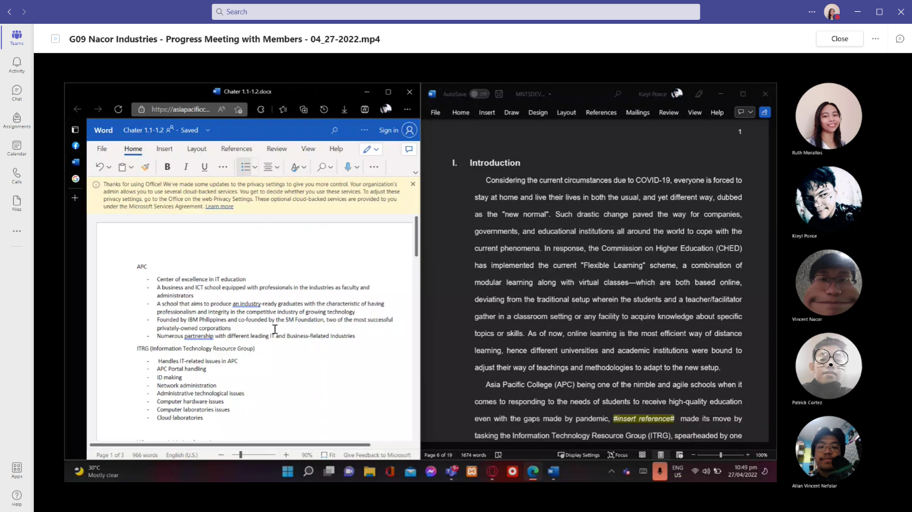

Figure 43 Microsoft Teams – Meeting with Members (4)

*Microsoft Teams – Progress Meeting with Members: May-22-2022*

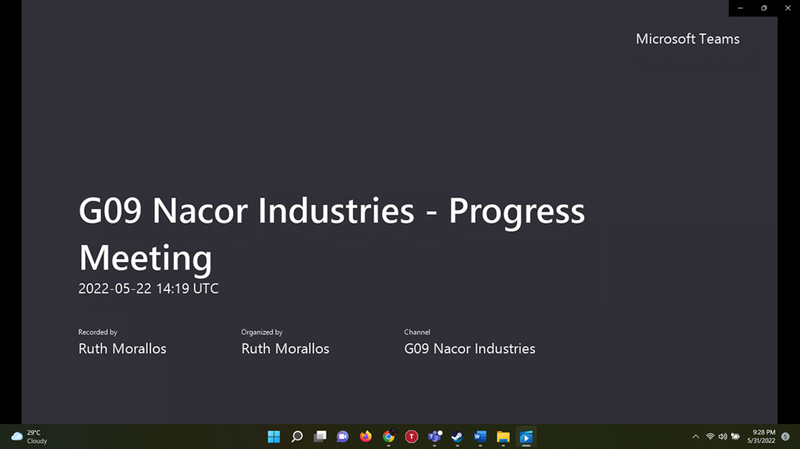

Figure 44 Microsoft Teams – Meeting with Members (5)

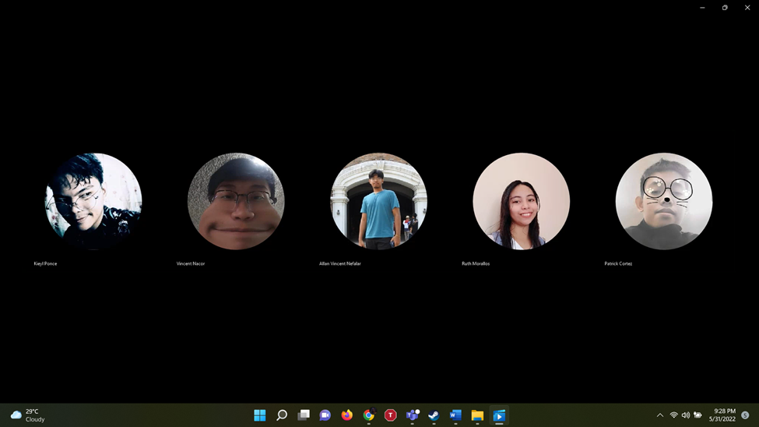

Figure 45 Microsoft Teams – Meeting with Members (6)

*Microsoft Teams – Meeting with Members: May-30-2022*

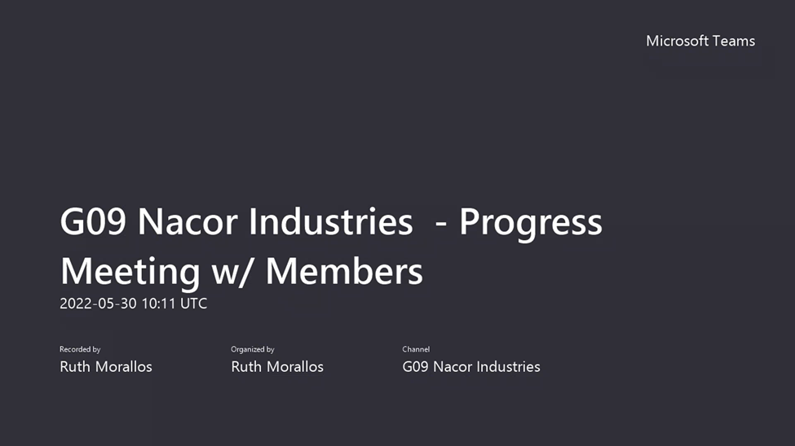

Figure 46 Microsoft Teams – Meeting with Members (7)

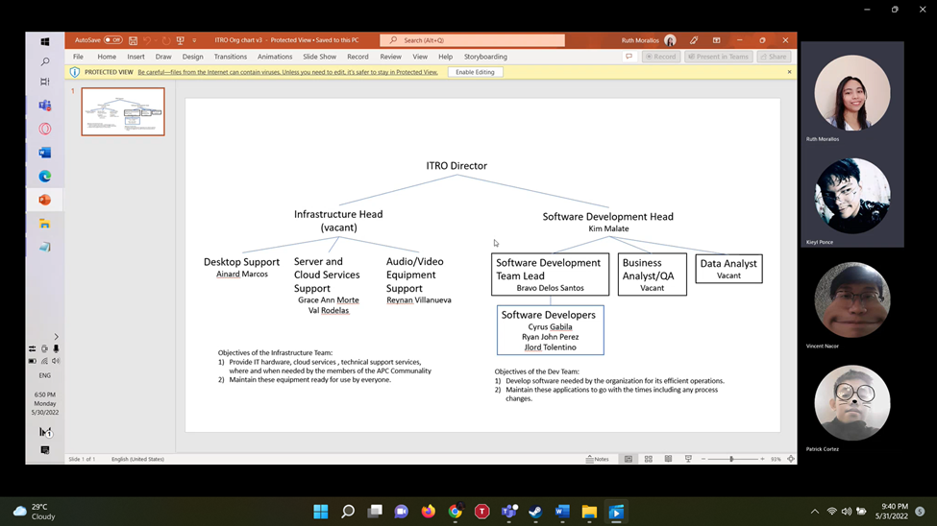

Figure 47 Microsoft Teams – Meeting with Members (8)

*Face-to-face – Meeting with Members:* May-31-2022

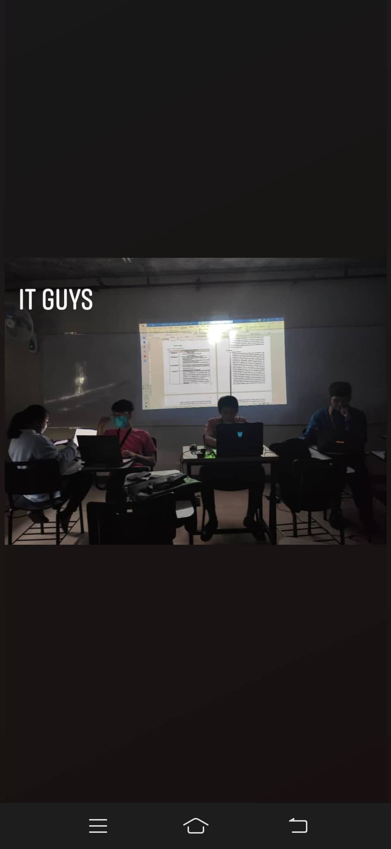

Figure 48 Face-to-face – Meeting with Members (5)

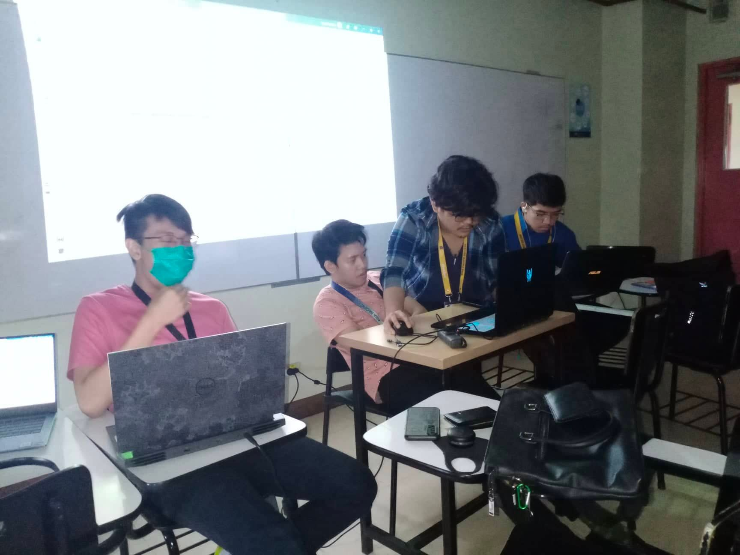

Figure 49 Face-to-face – Meeting with Members (6)

Table 8 Appendix B: Minutes of Meeting - Nacor Industries Members

|  |
| --- |
| **Minutes of the Meeting with Nacor Industries Members:** |
| **April 10, 2022** |
| Topics:   1. Project proposal features  * live chat * automated chat reply * categorization * prioritization (P1, P2...P3)  1. Prospect client  * ITRO * status update (if there is an agreed schedule for client meeting)  1. Proposal Documentation  * Setting meeting schedule with project adviser * Agreed Time: Tuesdays - 9:00 am * Setting up a f2f meeting with members * Agreed Time Tuesdays/Fridays - 8:00 am  1. Examples of Related System  * Help Desk (video about ticketing system)  1. Scope of the Project  * 1st Term – Documentation * 2nd term – Data Modelling * 3rd Term – Working Application |
| **April 19, 2022** |
| Topics:   1. Feature Planning  * suggestions from adviser  1. Paper Progress  * Problem Rundown * User Need Statement * Project Context(tentative) * Statement of the Problem(tentative) |
| **April 22, 2022** |
| Topics:   1. Feature Planning  * suggestions from client  1. Paper Progress  * Wireframe/Screens * Storyboarding * Chapter 1 |
| **May 22, 2022** |
| Topics:  A.    Client Statement Transcript   * + - * Questions       * Signed Answers |
| **May 30, 2022** |
| Topics:  A.    Update wireframe  -          Polishing wireframe of both mobile and web  -          Adding necessary functions in both mobile and web wireframe    B.    Reviewing the org chart  -          Reviewing the assigned tasks that people in ITRO do |
| **May 31, 2022** |
| Topics:  A.    Meeting with client  -          Meeting with Sir Jojo about SOP/Objectives  -          Interview with few questions regarding SOP    B.     Meeting with adviser  -          Discussed about how Ticketing Service works  -          Adding/Removing features in ticketing system  -          Polishing of papers    C.   Video Shooting  -          Gathered a few Clips for pitch video |

*Microsoft Teams – Meeting with Ms. Roselle Wednesday Gardon (Course Adviser):*

*Apr-11-2022*

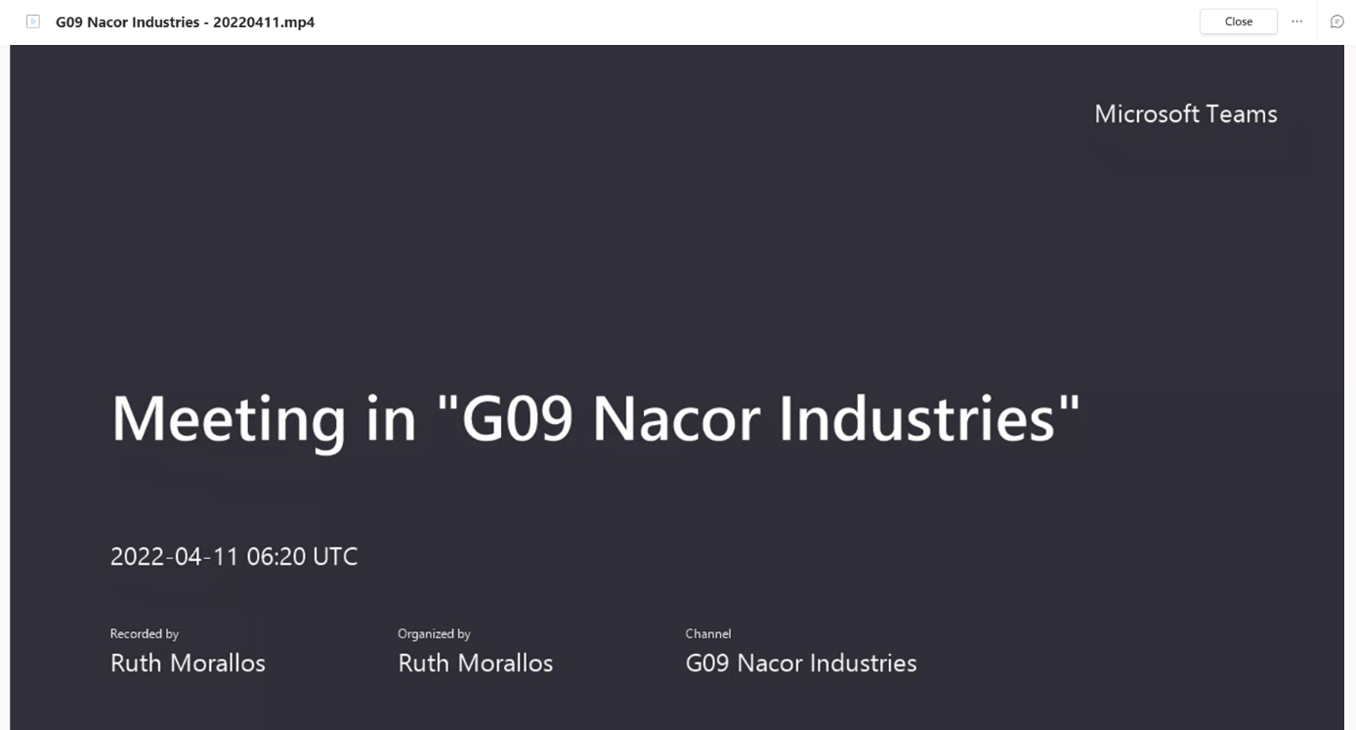

Figure 50 Microsoft Teams – Meeting with Ms. Roselle Wednesday Gardon (1)

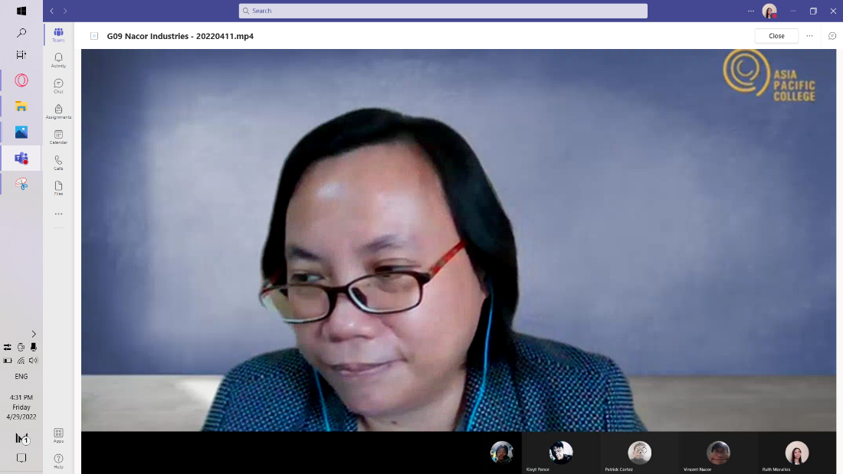

Figure 51 Microsoft Teams – Meeting with Ms. Roselle Wednesday Gardon (2)

*Microsoft Teams – Meeting with Ms. Roselle Wednesday Gardon (Course Adviser):*

*June-02-2022*

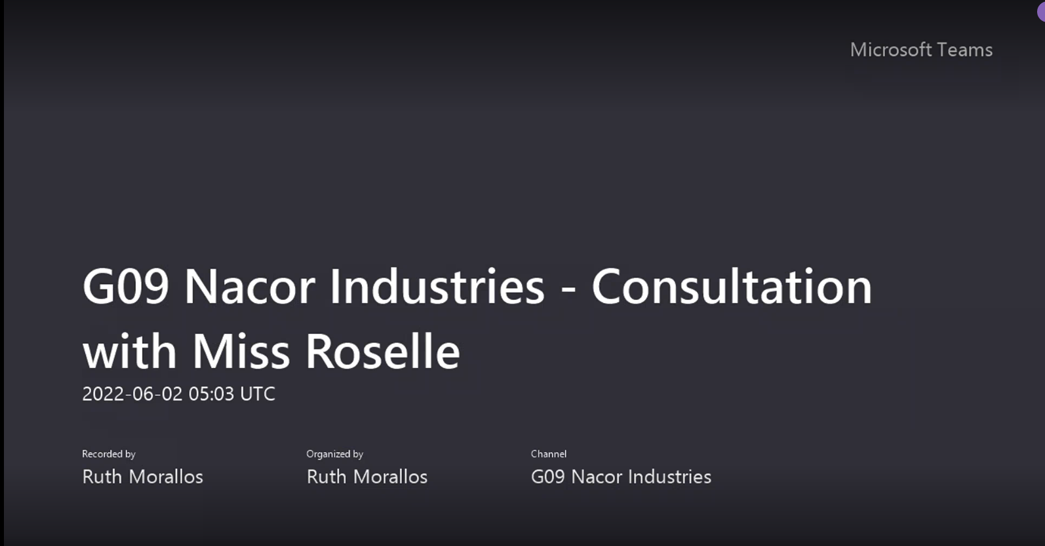

Figure 52 Microsoft Teams – Meeting with Ms. Roselle Wednesday Gardon (3)

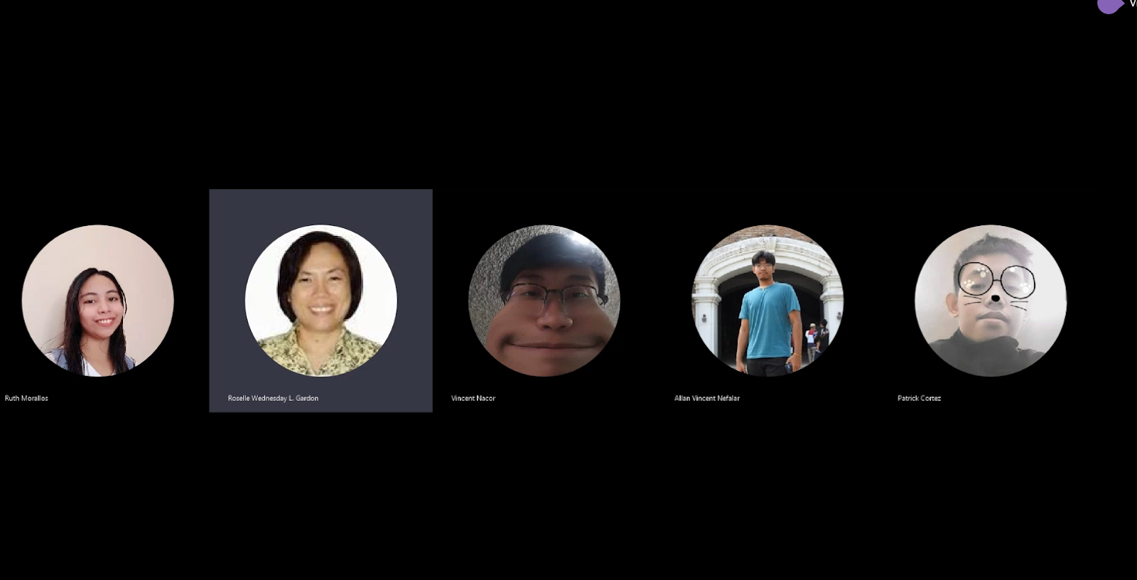

Figure 53 Microsoft Teams – Meeting with Ms. Roselle Wednesday Gardon (4)

Table 9 Appendix B: Minutes of Meeting - with Miss Roselle Wednesday Gardon

|  |
| --- |
| **Minutes of the Meeting with Miss Roselle Wednesday Gardon (Course Adviser)** |
| **April 10, 2022**  Topics:  A. Project update   * client update * What to finish:   1. Send an email   2. Follow up with proposal of the project in mind   3. Ask if the team can work with the client and if they want to customize the proposed plan   B. What is the project all about?   * ticketing service for requests and disputes   C. Signed form update   * Adding titles can be temporary |
| **June 2, 2022** |
| Topics:  A.    Meeting with Subject Adviser  -         Adding/Removing words for better grammar construction  -          Showing both mobile and web wireframe for approval  - Discussing possible questions from panelists |

*Face-to-face Meeting and Audio Recording Screenshot: – with Sir Alvin Limpin (Project Adviser): Apr-19-2022*

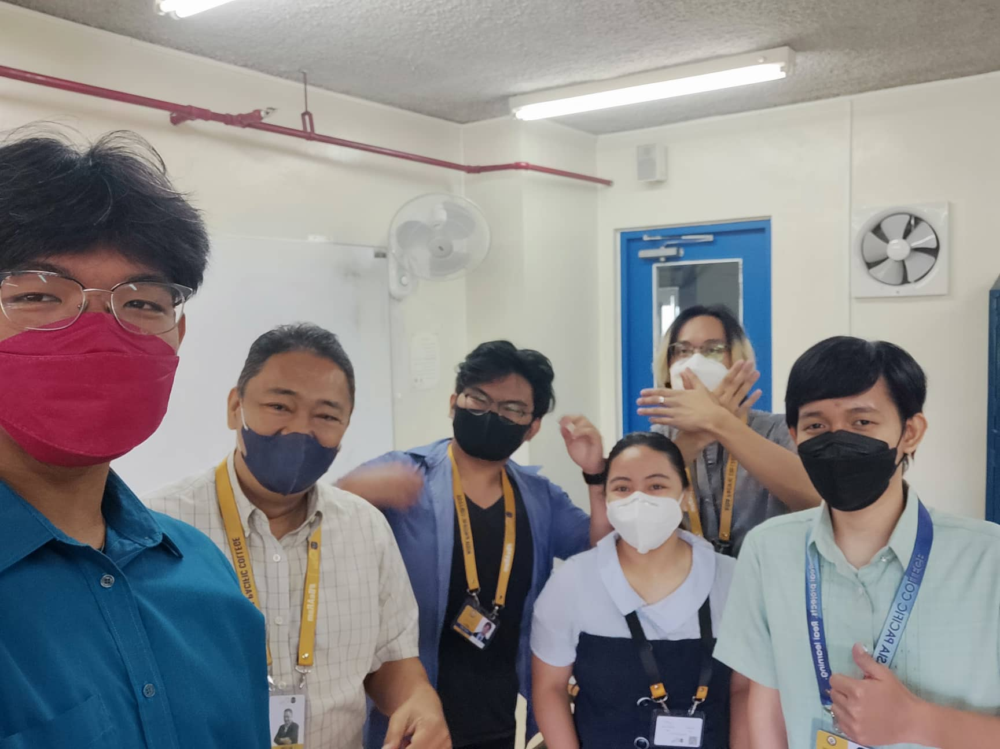

Figure 54 Face-to-face Meeting – with Sir Alvin Limpin (1)

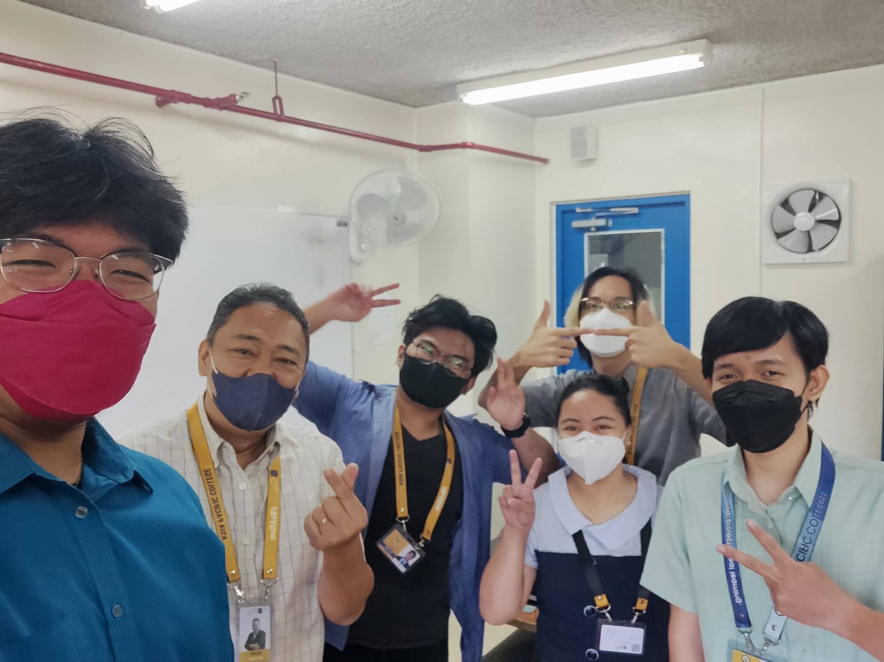

Figure 55 Face-to-face Meeting – with Sir Alvin Limpin (2)

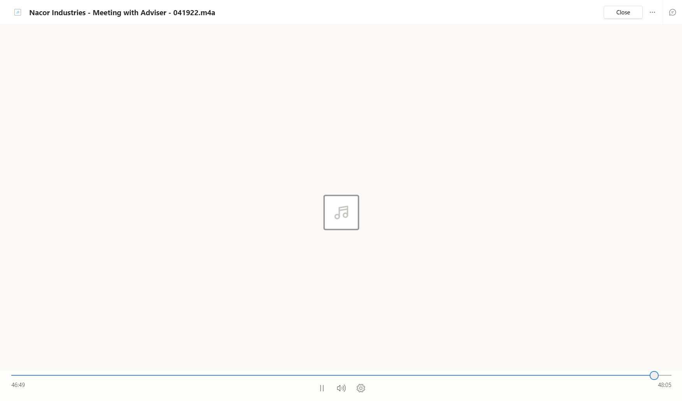

Figure 56 Audio Recording Screenshot - Meeting with Sir Alvin

*Face-to-face Meeting and Audio Recording Screenshot: – with Sir Alvin Limpin (Project Adviser): May-31-2022*

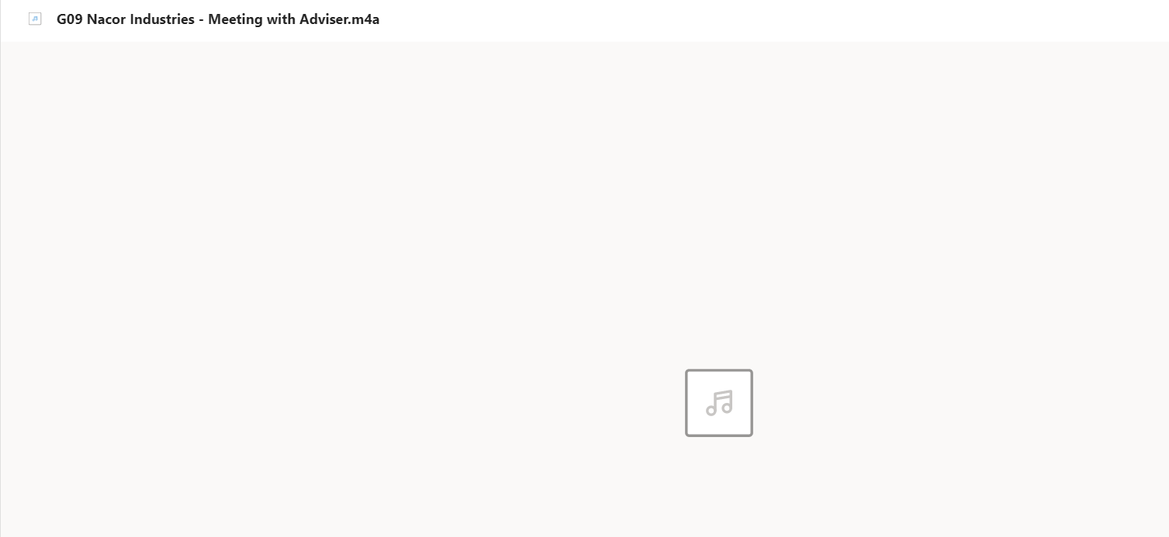

Figure 57 Audio Recording Screenshot - Meeting with Sir Alvin (1)

Table 10 Appendix B: Minutes of Meeting - with Sir Alvin Limpin

|  |
| --- |
| **Minutes of the Meeting with Sir Alvin Limpin (Project Adviser)** |
| **April 19, 2022**  Topics:   1. Where can ticketing system be used in APC  * overload works * plumbing * electrical * computers  1. Which department can the Ticketing System be applied to?  * security * building maintenance * ITRO * Department with overloading tasks  1. Client schedule inquiry  * who is the prospect client * When was the scheduled meeting for the client  1. What does ITRO do  * confirming IT-Related requests * laboratory fixes * computer issue * broken ports * issue in website * anything computerization * handling APC Website  1. Issue with ITRO Workflow  * hard to contact personnel * can be contacted via e-mail at most   F. Assume that in the ticketing system: how do these things work   * user sends a ticket in a form of e-mail to the client(admin) * email landing to the website on the backend/ITRO, * Admin gives priority to ticket * P1   * Most urgent  * Executives are losing money  * e.g., internet connection, mainframe is down   * P2... and so on * admin assigns the ticket to free personnel * monitoring tickets on a website * How can a ticket be sent: * Via email * via chat - automatic convert to email after sending   H. Review the following   * charts on how apps/ticketing system handles tickets   I. Create an algorithm on the following   * how to approve tickets * how to generate ticket reports |
| **May 31, 2022** |
| Topics:  A.    Meeting with Adviser   * + Discussed about how Ticketing Service works   + Adding/Removing features in ticketing system   + Polishing of papers |

*Face-to-face Meeting and Audio Recording Screenshot – with Sir Jose Castillo (Client – ITRO Head): Apr-22-2022*

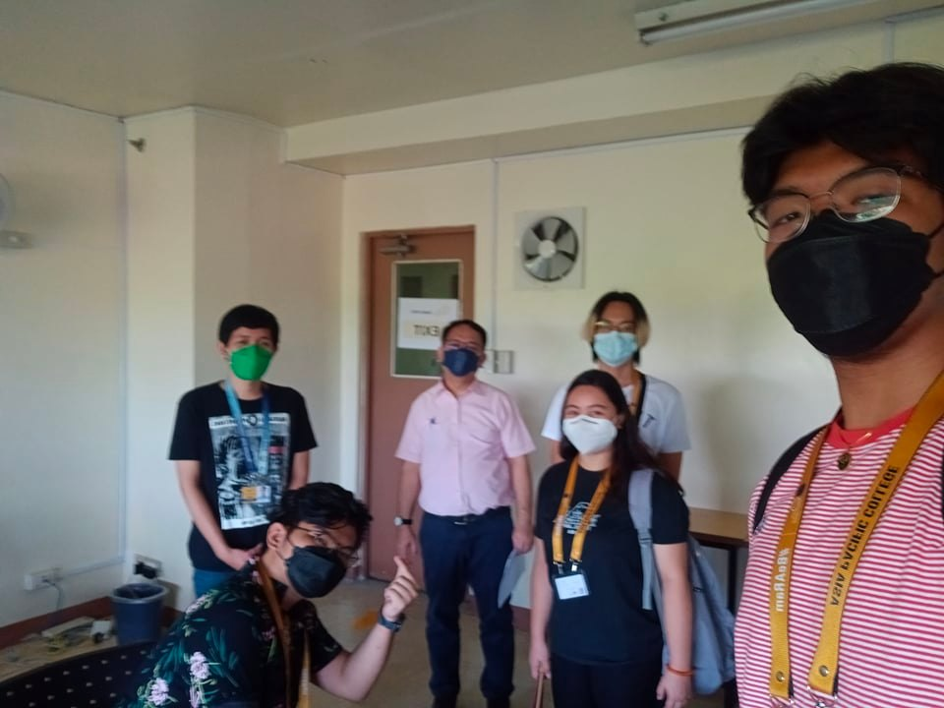

Figure 58 Face-to-face Meeting – with Sir Jose Castillo (1)

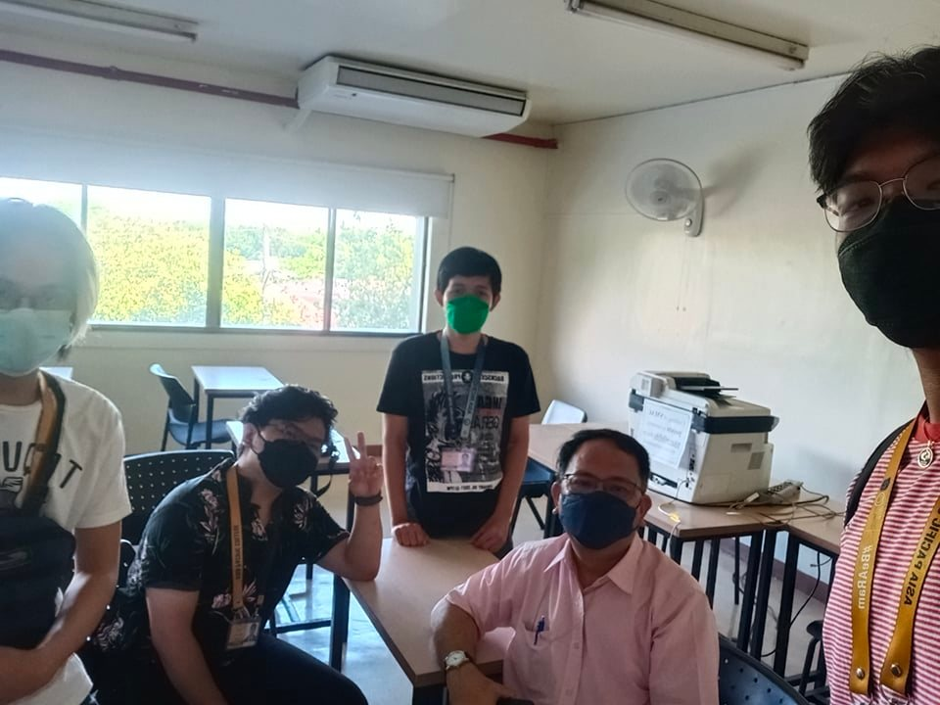

Figure 59 Face-to-face Meeting – with Sir Jose Castillo (2)

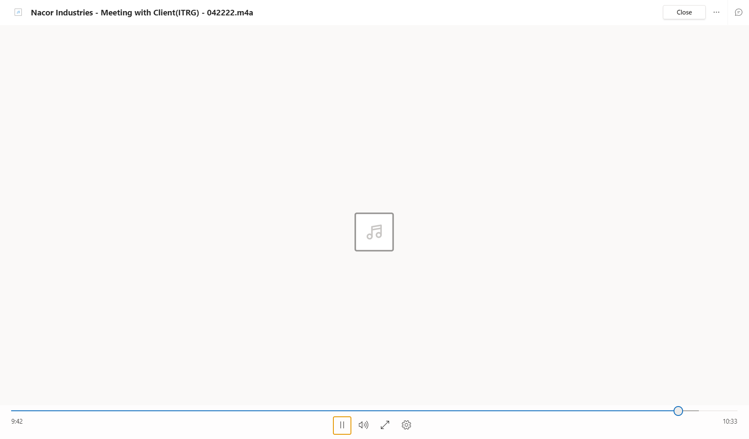

Figure 60 Audio Recording Screenshot - Meeting with Sir Jose Castillo

*Microsoft Teams Meeting Screenshot – with Sir Jose Castillo (Client – ITRO Head): May-10-2022*

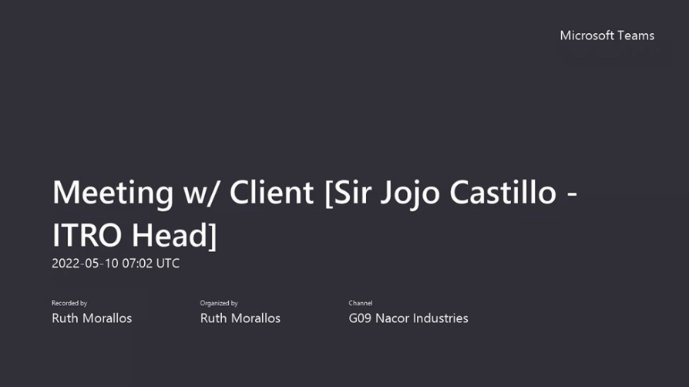

Figure 61 Microsoft Teams – Meeting with Sir Jojo Castillo (1)

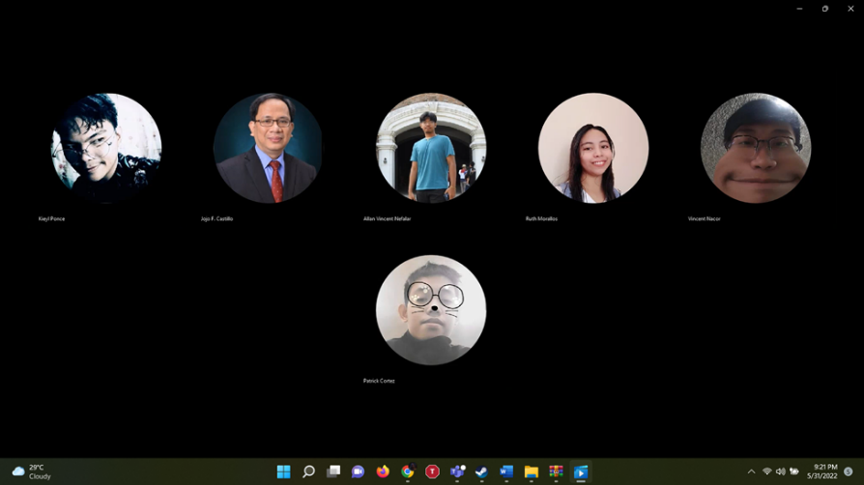

Figure 62 Microsoft Teams – Meeting with Sir Jojo Castillo (2)

*Microsoft Teams Meeting Screenshot – with Sir Jose Castillo (Client – ITRO Head): May-17-2022*

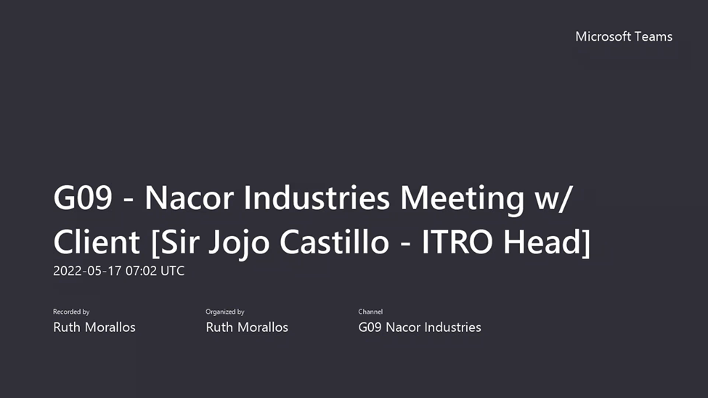

Figure 63 Microsoft Teams – Meeting with Sir Jojo Castillo (3)

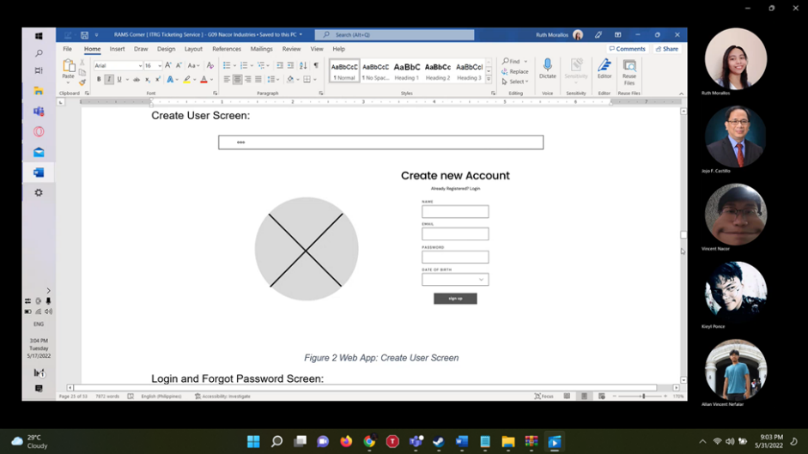

Figure 64 Microsoft Teams – Meeting with Sir Jojo Castillo (4)

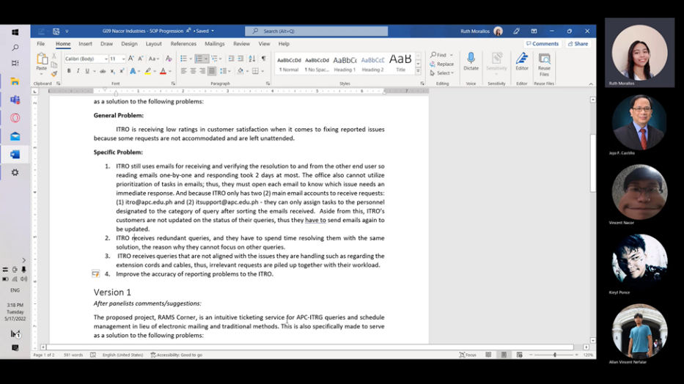

Figure 65 Microsoft Teams – Meeting with Sir Jojo Castillo (5)

*Microsoft Teams Meeting Screenshot – with Sir Jose Castillo (Client – ITRO Head): May-24-2022*

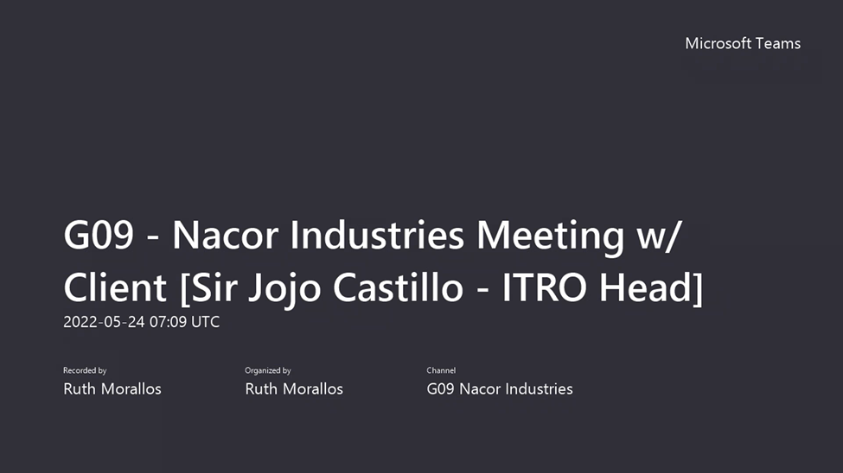

Figure 66 Microsoft Teams – Meeting with Sir Jojo Castillo (6)

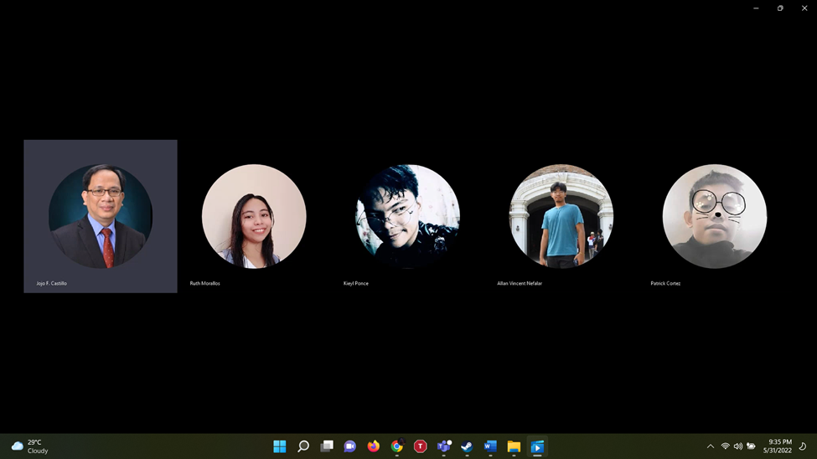

Figure 67 Microsoft Teams – Meeting with Sir Jojo Castillo (7)

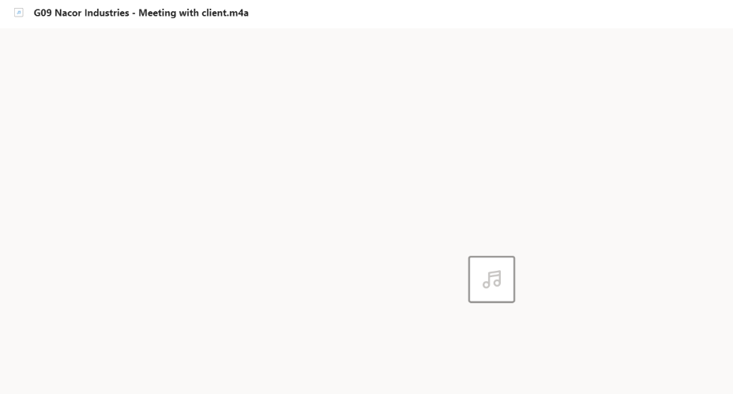

Figure 68 Audio Recording Screenshot - Meeting with Sir Jose Castillo (1)

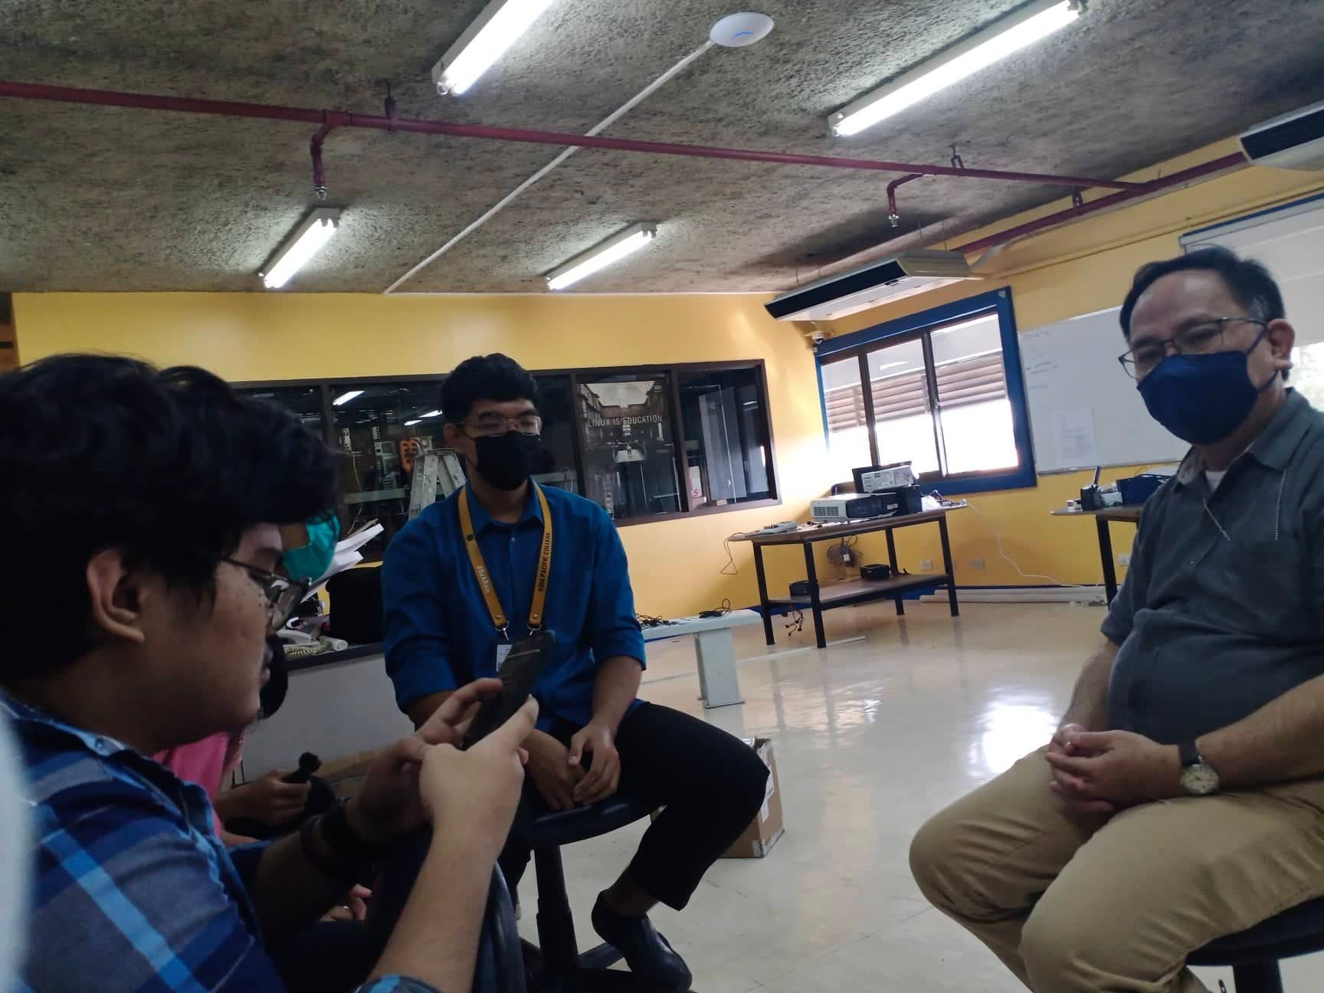

Figure 69 Face-to-face Meeting – with Sir Jose Castillo (3)

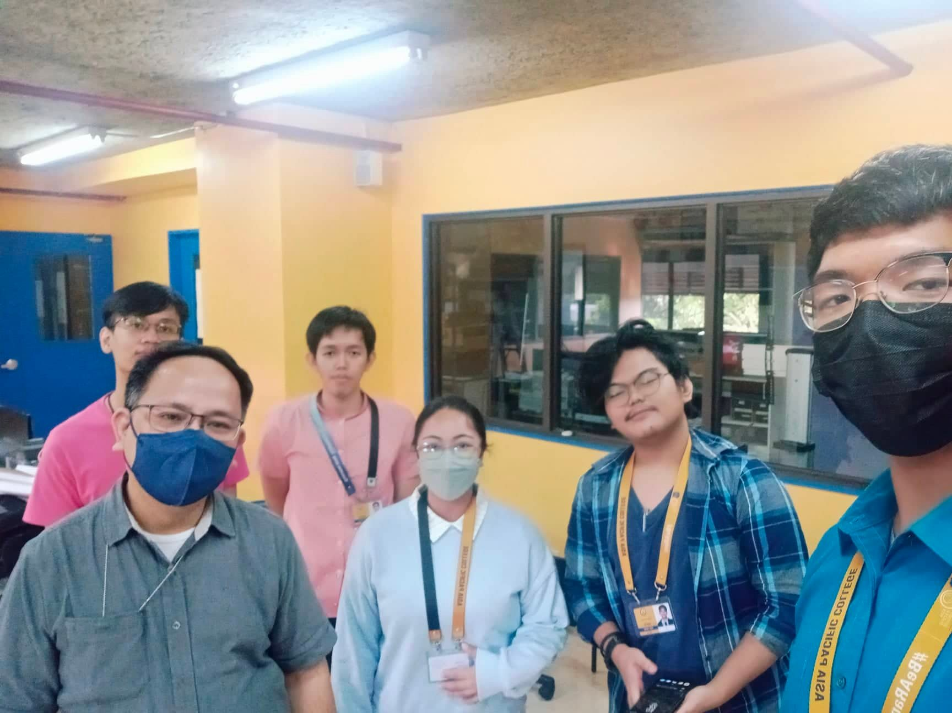

Figure 70 Face-to-face Meeting – with Sir Jose Castillo (4)

Table 11 Appendix B: Minutes of Meeting - with Sir Jose Castillo

|  |
| --- |
| **Minutes of the Meeting with Sir Jojo Castillo (Client)** |
| **April 22, 2022**  Topics:  A. what we are informed of about ITRO:  - lots of inquiries about system maintenance  - unattended emails  B. what we plan to do:  - mobile/web application ticketing system  - used by student/teachers  - can send queries with tags and captions/message  - if the question is common, there will be FAQs  - answers are provided by the client  - automated replies for usual questions in chat  - if needs personal assistance   * creating tickets based on schedule * tags for urgency   - admin   * layout of what request needs urgent replies   C. What we want to avoid:  - use of excessive emails  D. Ideas from the client:  + extend the features if possible   * + - * [add a picture]       * [picture recognition - AI (Artificial Intelligence)]       * [categorizations]       * [if any person reports - give feedback immediately]   + Notify both admin and user by following these steps or simply the feedback report from ITRO Wishlist:   * + - * [step 1: problem inspected]       * [step 2: pending request]       * [step 3: ongoing repair]       * [step 4: resolved]   + CC field for the teacher  + after the project - it can be maintained or used by the office and modify it based on the needs  E. What we should do before creating the app:   * + - * Try the systems       * make screenshots of trial software       * make a story on how to submit ticket onto the system       * think about how the system can be unique       * look for messaging trademarks and not make the algo from scratch       * develop the workflow       * do a mini survey from the students       * look at the problem from the user's side       * interview teachers       * ITRO wants to know what are the features that the user wants; design an algorithm based on the survey       * make a storyboard/wireframe |
| **May 10, 2022** |
| Topics:  A. Paper Progression  -          SOP Modifications  -          Specific Problem  B.    What we are informed About ITRO   * How ITRO Organize * Divided into Two Groups   A.    IT infrastructure  B.    IT Software Development   * Equipment Safe keeping * Lending IT equipment * Answer Technical Requests |
| **May 17, 2022** |
| Topics:  A.    Wireframe Design  1.    Website Admin  -          Create User Screen  -          Forgot Password Screen  -          Login Screen  -          Home Screen  -          Opened Request Screen  -          Insights Screen    2.    Mobile  -          Create User Screen  -          Forgot Password Screen  -          Login Screen  -          Filtered Ticket Screen  -          Open Request Ticket Screen  -          Home Screen  -          Help Center (FAQs) Screen    B.    Comment Matrix  -          Edit Comments  -          Improvements   * Old Version * New Version     C.   Paper Progress   * + Statement of Problem(tentative)   + Specific Problem(tentative) |
| **May 24, 2022** |
| Topics:  A.    Sent Paper To client  -          Document Checking    B.     Related System Gaps  -          Unique Application Feature (Rams Corner)   * CC field (Includes significant persons) * Automated Emails   + Click Specified Queries   + Accuracy & Uniformity   -          Freshdesk & Spiceworks   * Tagging Request * Assigning Request     C.   What to Use for Creating MVP  -          Out system (Reactive Web App)  -          Programming Language (Client Suggestion)   * Python * PHP * LinkedIn Resources (Recommended) * YouTube (Option)     D.   Document Follow Up  -          Analytic Data  -          ITRO Organization Chart |
| May 31, 2022 |
| Topics:  A.    Meeting with client  -          Meeting with Sir Jojo about SOP/Objectives  -          Interview with few questions regarding SOP  -      Consultation about automated response feature |

## Appendix C: Methodology

“A single methodology cannot be the only hammer to nail all the solutions.” Staying true to this belief, we have decided to make the most out of both waterfall and scrum methodologies by utilizing their best features and combining it using the water-scrum-fall method as seen in the figure below.

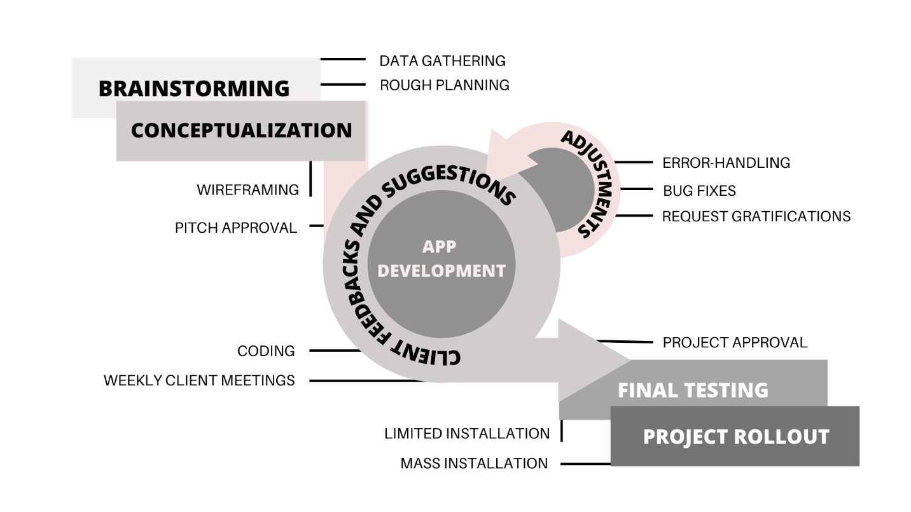

Figure 71 Scrum Methodology

In doing so, the potential flaw of being too linear could be ruled out since the team could always go back into coding and test it repeatedly for the client to see and adjust as soon as possible, minimizing any risk of the client having any regrets since they would be part of the process of making it in quite a literal sense.

Table 12 Tabular Schedule of Tasks

|  |  |
| --- | --- |
| **WEEK NO** | **TASK** |
| ***4*** | Adviser Confirmation |
| Project Proposal Brainstorming |
| ***5*** | Ticketing System Feature Ideas |
| Adviser Signed Form - Follow Up |
| Send e-mail to possible client |
| Meeting with Adviser |
| Problem Rundown |
| S.W.O.T Analysis |
| Wireframe/Storyboarding |
| Meeting with Client (ITRO) |
| User Needs Statement |
| ***6*** | Project Proposal: Chapter 1 & 2 - Compile |
| Intro & Abstract |
| Project Context |
| Statement of the Problem |
| Objectives |
| Significance |
| Scope and Limitations |
| RRL |
| Project Proposal: Chapter 3 & 4 - Compile |
| Project Proposal: Chapter 5 & Appendix - Compile |
| Project Proposal Proofreading and Editing |
| Project Proposal Completion |

In fact, almost the same methodology has been utilized towards making this very paper as seen in the team’s schedule in the figure above, where the blue parts depict ‘water’ and ‘fall’ respectively, while the yellow shaded cells are all done with scrum in mind, making the process both linear and direct, while staying collaborative.

## Appendix D: SWOT Analysis for RAMs Corner [ITRO Ticketing Services]

Table 13 SWOT Analysis for Rams Corner Ticketing Services

|  |  |
| --- | --- |
| RAMS CORNER TICKETING SERVICE APP  *(PROPOSED SOLUTION)* | |
| STRENGTHS | * Potentially much more convenient and intuitive * It has various features tailor-made for the client’s needs * Promotes a clean and modern user-interface free of clutter and advertisements that would help the user focus on what he needs to do. * Would be able to automatically respond to frequently asked questions without the need for manual replies. |
| WEAKNESSES | * Internet-dependent solution * Service is still based upon manual human response from the backend * Employees still need to learn the interface to fully-utilize the app |
| OPPORTUNITIES | * Since the project would be open source, the client could decide whether to commission other developers to improve the project even further or to publish it and give it even more features according to their needs or wants. |
| THREATS | * Considering that it is hard to get by the most tried and tested ways, some of the people involved (particularly the users) may decide not to use the application altogether and insist on sending emails instead. |